D7 Auto Service Center Web-App

Project Documentation Submitted to the Faculty of the

School of Computing and Information Technologies

Asia Pacific College

In Partial Fulfillment of the Requirements for

Applied Project – System Prototype for IT (Information Technology)

MCSPROJ

By

Viernes, Andre O. Garcia, Alyssa L.

Alfaras, Dan Michael C. Camino, Francesca Erin R.

ASIA PACIFIC COLLEGE

Approval Sheet

*D7 Auto Service Center Web-App*

Prepared and submitted by

|  |  |
| --- | --- |
| *Viernes, Andre O.* | *Garcia, Alyssa L.* |
| *Alfaras, Dan Michael C.* | *Camino, Francesca Erin R.* |

In Partial Fulfillment of the Requirements for the Degree of

Bachelor of Science in Information Technology

Examined and Recommended for Acceptance and Approval for

Research/Capstone Presentation

___________________________

Manuel Sebastian S. Sanchez, Adviser

Panelists

___________________________

<Name>, Chairperson

|  |  |
| --- | --- |
| ___________________________ | ___________________________ |
| <Name>, Panel Member | <Name>, Panel Member |

Acceptance and Approved in Partial Fulfillment of the Requirements for the Degree of

Bachelor of Science in Information Technology

___________________________

Rhea-Luz R. Valbuena

Executive Director

School of Computing and Information Technologies

Table of Contents

Table of Contents iii

Executive Summary v

List of Figures vi

List of Tables vii

I. Introduction 8

1.1 Project Context 8

1.2 Statement of the Problem 9

1.3 Objectives 10

1.4 Significance of the Project 10

1.5 Scope and Limitations 11

II. Review of Related Literature / Systems 11

III. Technical Background 14

3.1 Current System 14

3.2 Proposed System 15

IV. Methodology 18

4.1 Requirements Analysis 21

4.1.1 Product Backlog / User Stories 21

4.1.2 Event Tables 24

4.1.3 Use Case Diagrams 25

4.1.4 Use Case Full Description 26

4.2 Gap Analysis 35

4.3 System Analysis and Design 39

4.3.1 Context Flow Diagram 39

4.3.2 Data Flow Diagrams 40

4.3.3 Entity-Relationship Diagrams 43

4.3.4 Activity Diagram 44

4.3.5 Object Diagrams 45

4.3.6 Class Diagrams 46

4.3.7 Sequence Diagrams 46

4.3.8 Package Diagram 49

4.3.9 Component Diagram 50

4.3.10 Deployment Diagram 51

4.3.11 State Machine Diagram 52

V. Results and Discussion 53

5.1 Release Plan 53

5.2 Prototype 54

5.3 Use Classes and Characteristics 61

VI. Conclusion 61

References 63

VII. Appendices 65

Appendix A: Project Vision 65

Appendix B: Schedule 67

Appendix C: Product Roadmap 70

Appendix D: Data Dictionary 71

Appendix E: User’s Manual 72

Appendix F: Team Meetings 78

Appendix G: Source Code 84

Appendix H: Curriculum Vitae 85

Appendix I: Links 86

# Executive Summary

This project was created for the PBL (Project Based Learning) of the BSIT-MI Students of Asia Pacific College, and the group was named Elite Four. The group was with the purpose of learning throughout the project's duration, while they ensure a well-thought-out planning phase that ensures the project for their chosen client will be tailor-fit to the client's needs and addresses the requirements needed for the PBL of the group. It is also to their project phase where the team also ensured of the system analysis and design of the web-app are of quality and consistency with regards to the preparation being held for the deployment phase of the web-app. The project also has undergone testing and preparation for deployment, to ensure that it is well-documented and tested to be ready for implementation and deployment as it is going to be handed over to the chosen client of the Elite Four, which is the D7 Auto Service Center. The students in-charge of this project also extends out their gratitude towards the subject adviser, project adviser, and project consultant of the chosen project, as the advisers were the guidance that ensured that the project was of good quality, and the deliverables are ensured to be checked, revised, and corrected accordingly to meet the standards of the PBL requirements.

# List of Figures

Figure 1 Scrum Methodology Model [30] 18

Figure 2 Use Case Diagram 26

Figure 3 Context Flow Diagram 40

Figure 4 Data Flow Diagram: Service Reservation 41

Figure 5 Data Flow Diagram: Account Creation 42

Figure 6 Data Flow Diagram: Support Tab 43

Figure 7 Entity-Relationship Diagram 44

Figure 8 Activity Diagram 45

Figure 9 Object Diagram 46

Figure 10 Class Diagram 47

Figure 11 Sequence Diagram: Register & Login 47

Figure 12 Sequence Diagram: Admin Functions 48

Figure 13 Sequence Diagram: Reservation 48

Figure 14 Sequence Diagram: Review 49

Figure 15 Sequence Diagram: Support Tab 49

Figure 16 Sequence Diagram: View Web-App Details 50

Figure 17 Package Diagram 50

Figure 18 Component Diagram 51

Figure 19 Deployment Diagram 52

Figure 20 State Machine Diagram: Register & Login, Support Tab, and Service Reservation 53

Figure 21 State Machine Diagram: Reviews & Shop Details 53

Figure 22 Sign Up 55

Figure 23 Login 55

Figure 24 Customer Profile 56

Figure 25 Transaction History 57

Figure 26 Home Page 57

Figure 27 Services 58

Figure 28 Gallery 58

Figure 29 Reviews 59

Figure 30 FAQs 59

Figure 31 About Us 60

Figure 32 Reservation Form 60

Figure 33 D7Cares 61

Figure 34 Dashboard 61

Figure 35 Data Dictionary 73

# List of Tables

Table 1 Current System Processes 14

Table 2 Agile Scrum Team 18

Table 3 Scrum Methodology Description 19

Table 4 Product Backlog / User Stories 21

Table 5 Event Table 24

Table 6 Use Case Full Description: Login System 27

Table 7 Use Case Full Description: Support Tab 28

Table 8 Use Case Full Description: Service Reservation 29

Table 9 Use Case Full Description: Reviews 31

Table 10 Use Case Full Description: Shop Details 32

Table 11 Use Case Full Description: Manage Web-App 33

Table 12 Use Case Full Description: Statistics 34

Table 13 Gap Analysis 36

Table 14 Release Plan 54

Table 15 Use Classes and Characteristics 62

Table 16 Schedule 69

Table 17 Product Roadmap 72

# Introduction

## Project Context

The project titled “D7 Auto Service Center Web-App" is focused on developing a solution for the management of D7 Auto Service Center. D7 Auto Service Center is a part of the automobile repair industry, which focuses on maintenance and repair of vehicles. The project was started for the very reason of helping D7 with their struggles in keeping up on how they could make customers acquire their services. D7’s Management currently uses Facebook as their medium for advertising their offered services, and this has been exceedingly difficult as the team is limited to one platform alone, and its ever-changing algorithm [1];which keeps them from being able to maximize advertising and functioning online. Furthermore, another concern that D7 has is with the management of bookings. There are times that the staff struggled with the organization of reservations as booking processes were manually recorded and kept track of, which sometimes causes concerns with D7’s record keeping because of the lack of centralization of this process. These problems, together with the concern about how they may have more interactions with their clients/potential customers besides their current activities limited to their current platform. The project aims to improve their current systems for advertising by having an added platform to add online presence. Furthermore, the project will also have useful features implemented that will help D7’s management have a convenient booking system, to address their service status tracking and management, by having an online reservation system, as well features that will help in the decision making for the improvement of the overall services of the business to customers. D7 can now use both platforms (Facebook and the D7 Auto Service Center Web-Application) to work together to have better customer reach, engagement, and management.

## Statement of the Problem

The problems that the team aim to address are:

(1) The company is struggling with their advertising and online presence on their current system (Facebook), because most of their competitors do the same promotions and use the same platform. Despite the effort to step up advertising and customer reach, the company is still afflicted by the current system’s ever-changing algorithm which lessens their customer reach in the platform [1].

(2) The company is experiencing difficulties with regards to management and keeping track of reservation, because the customers are using various tools to make a reservation, such as their Gmail, via mobile text, Facebook Messenger and even walk-ins. This causes concern for the company because the admin does not have a centralized system which often causes inconsistencies and errors in the recordkeeping, making it difficult to manage and retrieve information. Additionally, manually collating information from different channels can be time-consuming and increases the risk of losing important data, that can result in disorganization of customer service and potential loss of revenue. [2] [3] [4].

(3) Since the pandemic came, the online competition has been stiff for D7, which is why the struggle to attract more customers has been a long-term problem of D7.

## Objectives

**Main Objective**

The Elite Four’s mainobjective for D7 Auto Service Center is to provide a solution that caters totheir need to expand their online presence, which alsoaddresses D7’s long-term concern regarding managing customer reservations, as well as their struggle regarding newideas for customer engagement.

**Specific Objectives**

* To increase customer reach by up to 50% within the first three months of deployment of the web-app by leveraging an additional online platform. [2] [3] [4] [5]
* To develop a centralized system for D7 to manage the bookings of their customers and allow their customers to request reservations 24/7. [6]
* To extend the Auto Service Center’s support for their customers, as well as potential customers, through an environment where both customers and D7 specialists can converse. [7]

## Significance of the Project

The beneficiaries of the project will be:

* D7 Auto Service Center Marketing & Management Team – As this project will help them have another platform that they can use to increase customer reach and engagements, as well as management of the business online.
* D7’s Clients – With the enveloped features of the website, this project will supply features like 360° virtual tour, to view the establishment at the comfort of their own home.
* The project does not only build more value and credibility to the business, but also adds more functionalities and online presence, which 76% of people look for before visiting onsite, according to a study from Cison in 2021 [8].
* The project also addresses SDG no. 9 which focuses on Innovation, as we use a web-app to meet the needs of D7, and further implement innovative features to make the web-app more useful for the client [9].

## Scope and Limitations

The project is limited to and focused on creating a web-app as platform for advertising and managing D7 Auto Service Center. The web-app is also in the scope for development with features that are, but not limited to: reservation system for the transactions, statistics, login system, customer profiles, review/feedback section, mobile optimization, supports tab, site locator, service gallery, social media buttons, 360° virtual tour, and listing of services offered. Since the project is in the practice of the Agile method, the limitations and scope, as well as features of the project are subject to change. ￼

# Review of Related Literature / Systems

In this chapter, the researchers covered the various related literature and relevant studies that were thoroughly studied by the team. This section consists of concepts, findings, methodologies, and other resources with comparable results and features to the proposed solution entitled "D7 Auto Service Center Web-App".

Creating a web-app for a small company has a significant impact on the business industry, as it helps to build business value and credibility. The related literature proves how a web app supplies convenience in communication to both managers and consumers while building customer trust. For example, Hartford research “Developing a Website for Durian Seed Marketing: Alternative Business Media During a Pandemic,” [10] a study “Developing a website for online consumers to find foreign businesses in Finland,” [11] and an article of December Communication Inc. [9] All the studies said that web-app is beneficial to a business because it enables the business to express the brand’s value. Furthermore, the studies mentioned that a business could not survive without a web presence because a web-app in the business world is needed to stand out from other competitors [10]. These studies are relevant to the ongoing project in a way, how features will be used and be helpful to the creation of the web-app.

To further strengthen the study, the team was able to review the related systems to the ongoing project. Having an added web-app proves that the system can use plenty of features. For example, the Yellow Bird Auto Center website, the Pioneer Auto Repair shop website, the Galson Auto Body website, the Rapide Auto Service Experts, the Centennial auto services, Inc., and the MechaniGo.ph holds common features that help use the website, such as a gallery, Google maps, branch locator, reservation, and social media buttons [12] [13] [14] [15] [16] [17]. In contrast, the project D7 web-app could have features not present in the systems reviewed, such as a 360° virtual tour, and the D7 cares community. These related systems are pertinent to the project because they support how the features supply convenient navigation to users.

To summarize this chapter, the team aims to build business value and credibility for the D7 Auto Service Center with a review of related literature. According to Hartford, Clark, and December Communication Inc., the web-app eases communication between customers and managers. It also proves how having a web-app can help a business to stand out from its competitors [10] [18] [9] [19]. Also, "New Study Highlights the Importance of Online Reviews in Local Search" and Jordan. They all said how reviews affect customers' decisions when buying an item [20] [8]. The team reviewed local and foreign-related systems and compared them to the proposed web-app's features. The team found out that some of the related systems are not yet using some features that are going to be used in the web-app like in the Yellow Bird Auto Center, the Pioneer Auto Repair shop, Galson Auto Body, Rapide Auto Service Experts, the Centennial Auto Services, and MechanicGo. All of them do not have a 360° virtual tour, and most of them do not have a support tab and reviews and feedback. Furthermore, the team will use the findings and said features to implement innovative features to make the web-app more useful to D7 Auto Service Center and help it stand out among its competitors.

# Technical Background

This chapter will discuss the current system which the company has and as well as what the team’s proposed solution to aid the company’s system. This discussion will cover the system’s hardware, software, network, and people.

## Current System

The D7 Auto Service Center’s current system involves face-to-face transactions in their services; they also manage service reservation requests on-site and through Facebook messenger. Facebook is also the company’s only online platform to manage their customers' needs online — this includes booking services, review section, and inquiry.

Table 1 Current System Processes

|  |  |  |
| --- | --- | --- |
| Process ID | Process Name | Process Description |
| P001 | Answer Inquiry via Facebook and Onsite | The management team answers the inquiries of the customers. |
| P002 | Reservation Acknowledgement via Facebook and Onsite | The management team accepts or declines reservations from the customers. |
| P003 | Posting Customer Vehicle via Facebook | The management team posts images to show appreciation for their customers, as well as to display numbers of services they have given. |

## Proposed System

**Technicality of the project**

The team will be using a web-based program wherein the users can access it through a browser, best displayed on a PC (Personal Computer) or Laptop; but with the aim to make it optimized for access through mobile devices like a smartphone and a tablet in the future. The D7 Auto Service Center Web-App is an added platform for management and customer needs. These are the technological tools that will be used in the system: VS Code – Text Editor, Server-client side – PHP, HTML (Hypertext Markup Language), CSS (Cascading Style Sheet), Apache – Xampp, Database – MySQL (Standard Version), Functionality – Web application, PhpMyAdmin. GitHub will be used for team collaborations. For the future use of the proposed system, the team recommends the company to use Microsoft Azure for the cloud computing services this is because accessible data, automated syncing, ease of remote work, and simple backups are a few advantages of cloud computing for small enterprises.

**Details of the technologies to be used**

Any technology, including mobile phones, laptops, tablets, and PCs (Personal Computer), will be able to run this project. Future users of the project should be digitally literate and have a good and stable internet connection to be able to use the project. In developing the project, the following technology tools will be used.

* **VS Code –** will be used to code the system so that data and information are acquired accurately and quickly [21].
* **PHP -** a general-purpose scripting language suitable for server-side web development, where it typically executes on a web server. It can also be applied to client-side GUI programs and command-line scripting [22].
* **Xampp -** To allow website designers and programmers to test projects locally [23].
* **MySQL (Standard Version) -** An open-source relational database management system, to be used as it is one of the system development compatible databases [24].
* **Apache -** well-known for being essential to the early development of the World Wide Web [25].
* **HTML –** the most basic building block of the web. A markup language used to create web pages and web applications [26].
* **CSS -** a style sheet language responsible for the visual presentation of documents written in a markup language [27].
* **GitHub –** to be used for code hosting for version control and collaboration [28].
* **Bootstrap** - to be used for developing a responsive and mobile-first website [29]

**How the proposed system will work**

For organizations of any size, a web application is helpful since it does not only supply value and legitimacy but also eases work and record keeping. A web-app functions as follows: the user must first have a strong internet connection, access a device with a browser, and enter D7’s web-app link. Following this, the user should be on the web-app's home landing page. In building the web-app, the team has decided not to use website builders, such as Wix, and WordPress. This is because using these web builders negates the goal of giving the client more power over the UI/UX design they want. Despite this choice, the team will continue to use ready-to-use, publicly accessible source code rather than hard coding everything. In addition to coding and design, creating a web application also requires selecting a company's domain name, web host, and how to link all the required resources. The creation of the web-app will not drop the current system the company has but connects with their current system and supply features their current system does not have. In managing the company’s web-app the management will have an administrator who will manage the company’s web-app.

# Methodology

Figure 1 Scrum Methodology Model [30]

**Agile Scrum Team**

Table 2 Agile Scrum Team

|  |  |
| --- | --- |
| Role | Name |
| Team Leader/Scrum Master | Andre O. Viernes |
| Product Owner | Dan Michael C. Alfaras |
| Scrum Team | Alyssa L. Garcia  Dan Michael C. Alfaras |
| Stakeholder | Francesca Erin R. Camino |

**Scrum Methodology Description**

Table 3 Scrum Methodology Description

|  |  |
| --- | --- |
| Steps | Descriptions |
| Scope | The team has planned to have the following features for the web-app: a reservation system for transactions, statistics, a login system, customer profiles, a section for reviews and feedback, mobile optimization, a support tab, a site locator, a gallery of services, social media buttons, a 360-degree virtual tour, news and promotions, and a list of services. |
| Product Backlog | The team has listed everything the product needs to satisfy the client and customers to have deliverables discussed in Sprint Meetings. |
| Design | The team will be using the knowledge learned from System Analysis and Design (MSYADD1) to design the UI (User Interface) and UX design of the system. |
| Sprint Planning Meeting | The team will have a meeting, which is held at the start of each sprint, to decide how the project will be approached based on the phases and deadlines in the Product Backlog. |
| Sprint Backlog | The team when in the sprint backlog will be working on a subset of the product, and the team will review the list of work items that are to be completed in the specific sprint. |
| Sprint Automation | The team in the sprint automation will start testing activities at least one sprint behind the development phase, and the features/functionalities of the web-app will be tested once it is stable. |
| Daily Scrum | The team will have a daily standup to show the plans and the things that need to be carried out, as well as to see hindrances towards the completion of the work, as well as progress updates on the current work of the team. |
| Sprint Execution | The team will have and manage a task plan, perform, and finish the tasks, attend daily stand-ups, as well as have continuous communication with the scrum team. |
| Sprint Review Meeting | The team members are set to have daily quick meetings to review informal demos and present the work they have done for the iteration. |
| Sprint Retrospective | The team will examine what went well during the last sprint cycle and what may be improved for the next sprint. |
| Usable Software | The team is set to release the usable software - which is the proposed system, for use. |

## Requirements Analysis

### Product Backlog / User Stories

Table 4 Product Backlog / User Stories

|  |  |  |  |  |  |
| --- | --- | --- | --- | --- | --- |
| **ID** | Priority | Title | User Stories | Acceptance Criteria | Estimate |
| **1** | Must | Login System | As a customer I want to be able to make an account for the web-app so that I can access the features of the web-app and login for the features that requires an account. | Given the customer is on the registration page, he/she can create an account. | 3 |
| **2** | Must | Login | As a customer I want to be able to login to the web-app so that I can make an appointment and write a review. | Given the customer is on the login page when he/she fills up the username and password correctly and clicks the <Login>  then he/she will now be logged into the web-app. | 1 |
| **3** | Must | Service Reservation | As a customer I want to be able to make an appointment so that I can be free from having to wait in line to start a transaction. | Given the customer is in the reservation form and has logged in to his/her account when he/she fills out the reservation form. | 3 |
| **4** | Must | Reviews | As a customer I want to be able to write a review about the establishment’s services so that I can leave my reviews to help them improve their services. | Given the customer is in the review section and logged into his/her account when he/she clicks the <Write Review> then he/she can write a review. | 3 |
| **5** | Must | Web-App Details | As a customer I want to be able to know more about the establishment’s available services and shop details so that I can easily decide if I want to avail themselves of their services or not. | Given the customer was able to navigate the web-app when he/she visits the web-app then he/she can view and navigate the services and shop details. | 5 |
| **6** | Must | Statistics | As an Admin/Management I want to be able to view the statistics of the web-app so that I can find out if the service center is performing well. | Given the Web-App has visitors and customers when Admin/Management clicks <dashboard> then he/she can view the statistics of the web-app. | 5 |
| **7** | Must | Manage Web-App | As an Admin/Management I want to be able to Manage my web-app so that I can Add, Read, Update, and Delete any content I want in the Web-app. | Given the Admin/Management has logged into their admin account the dashboard is at once displayed to perform CRUD operations. | 8 |

### Event Tables

Table 5 Event Table

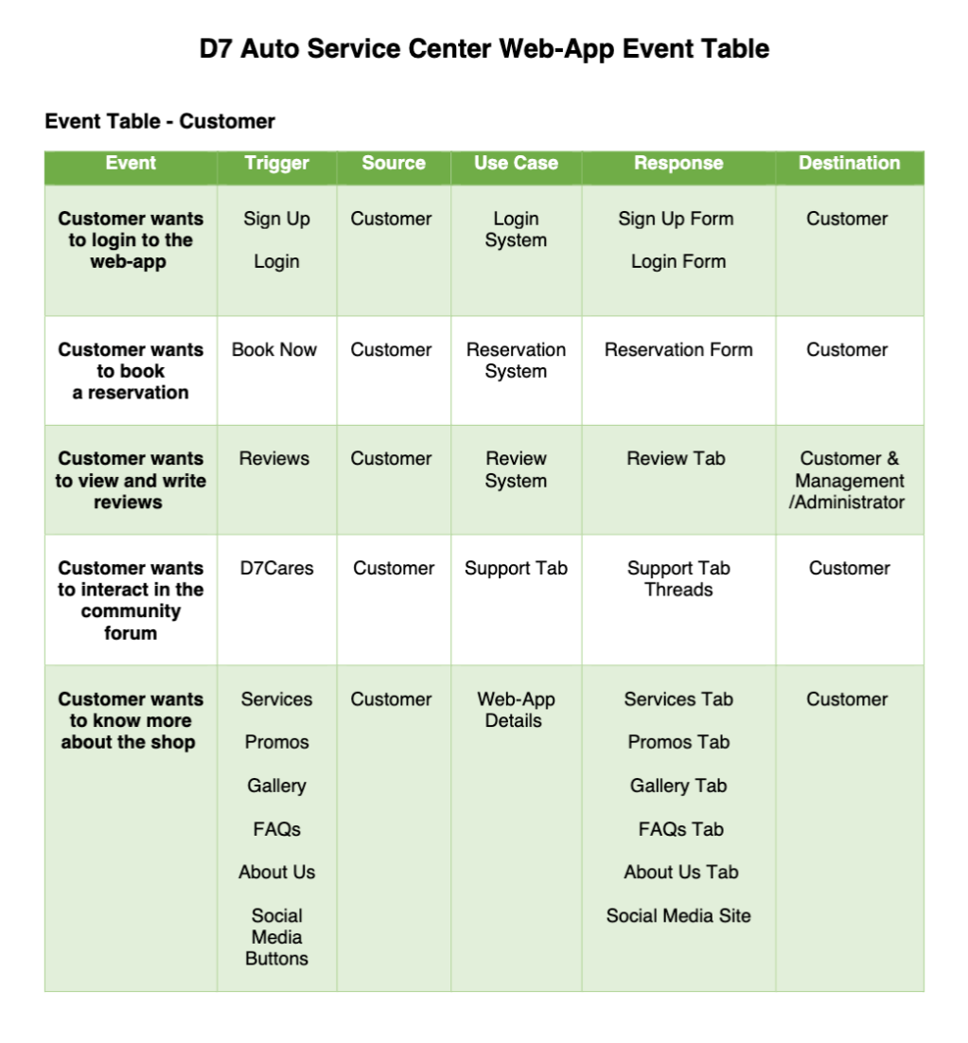

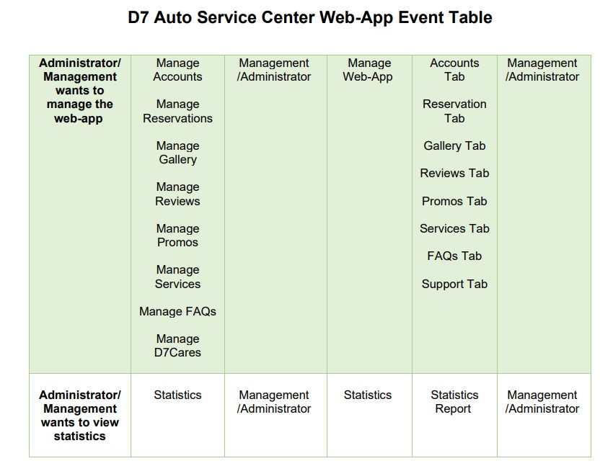

### Use Case Diagrams

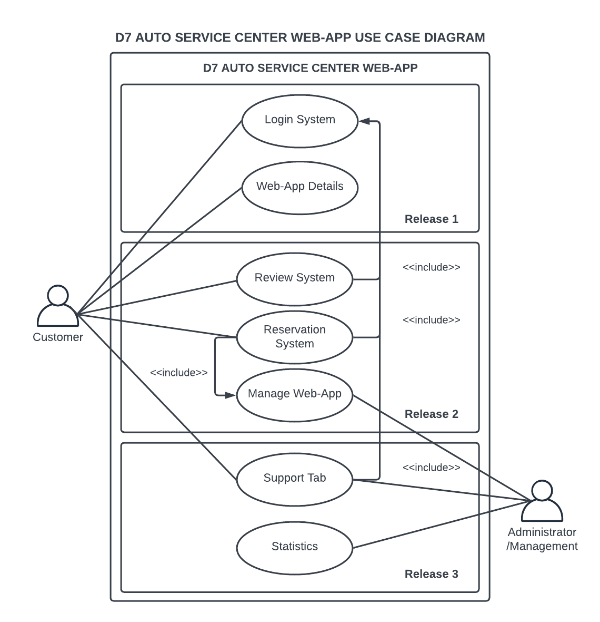

Figure 2 Use Case Diagram

### Use Case Full Description

Table 6 Use Case Full Description: Login System

|  |  |  |
| --- | --- | --- |
| Use Case Name: | Login System | |
| Scenario: | Customer creates an account/log into account | |
| Triggering Event: | Login/Register | |
| *Brief Description:* | Customer visits web-app for the first time, then decides to create an account for acquiring services of the D7 Auto Service Center. | |
| Actors: | Customer | |
| Related Use Cases: | - | |
| Stakeholders: | Customers, Administrators/Management | |
| Preconditions: | 1. Customer must be on the web-app homepage 2. Customer must click the sign-up button 3. Customer must input credentials | |
| Postconditions: | 1. Confirmed Account created must reflect on system  2. Account must now be accepted for login | |
| Flow of Activities: | Actor | System |
|  | 1. Customer Visits D7 Web-app   2.1.1 Customer clicks sign up button  3.1.1 Customer must input needed credentials for account creation  3.2.3 Customer is notified of accepted input  4.1.2 Customer clicks confirmation link  4.3 Customer can now input credentials to login | 1.1 System displays web-app home page    2.1 System prepares sign up window    3.2 System records customer gave info  3.2.2 System records data and sends notification to user of accepted input  4.1 System sends a confirmation email to the user |
|  |  |
|  |
|  |  | 4.2 System activates account registered |
| Exception Conditions: | 1. Customer cannot sign up if offline  2. Customer cannot login without | |

Table 7 Use Case Full Description: Support Tab

|  |  |  |
| --- | --- | --- |
| Use Case Name: | Support Tab | |
| Scenario: | Customer uploads a query in the D7Cares Community | |
| Triggering Event: | Submit Question | |
| Brief Description: | Customer visits web-app; logs into account, then proceeds to write query, then submits it, followed by replies from the community and/or the web-app admin. | |
| Actors: | Customer | |
| Related Use Cases: | - | |
| Stakeholders: | Customers, Administrator/Management | |
| Preconditions: | 1. Customer must be on the web-app homepage 2. Customer must have an account to submit a query 3. Customer must click the D7 Cares Tab | |
| Postconditions: | 1. Query submitted must reflect on system and notify user with a toast | |
| Flow of Activities: | Actor | System |
| 1. Customer Visits D7 Web-app     1.2 Customer clicks D7 Cares Tab  2.1.2 Customer clicks button to submit a thread  3.1.2 Customer inputs needed information and submits thread  4.1 Customer is notified of successful posting of thread via toast | 1.1 System displays web-app home page    2.1 System loads posts in the community  3.1 System loads form for submitting a thread  3.2 System records customer given info and pops up a toast to customer  4.2 Submitted thread reflects on the system |
| Exception Conditions: | 1. Customer cannot post if offline  2. Customer cannot post/reply if not logged in | |

Table 8 Use Case Full Description: Service Reservation

|  |  |  |
| --- | --- | --- |
| Use Case Name: | Reservation System | |
| Scenario: | Customer wants to book a reservation | |
| Triggering Event: | Book Now | |
| Brief Description: | Customer decides to book a service and the date of that servicing | |
| Actors: | Customer | |
| Related Use Cases: | Login | |
| Stakeholders: | Customers, Administrators/Management | |
| Preconditions: | 1. Customer must be logged into account 2. Customer must choose a service 3. Customer must choose a date for the service | |
| Postconditions: | 1. Customer receives reservation request details via email | |
| Flow of Activities: | Actor | System |
| 1. Customer Visits D7 Web-app     1.1 Customer logs into account    2.1.1 Customer clicks book now    3.1 Customer inputs reservation details  4.1 Customer is notified via email of successful request for reservation | 1.1 System displays web-app home page  2.1 System logs host to customer profile    2.2 System prepares reservation prompt and form  3.2 System confirms if reservation details are acceptable  3.3 System saves and records reservation details |
| Exception Conditions: | 1. Customer cannot reserve if offline 2. Customer cannot reserve if logged out 3. Customer cannot reserve if service is unavailable 4. Customer cannot reserve if date is unavailable | |

Table 9 Use Case Full Description: Reviews

|  |  |  |
| --- | --- | --- |
| Use Case Name: | Review System | |
| Scenario: | Customer wants to view and write reviews | |
| Triggering Event: | Review | |
| Brief Description: | Customer decides to view reviews given by customers, and/or write a review in the reviews section. | |
| Actors: | Customer | |
| Related Use Cases: | Login | |
| Stakeholders: | Customers, Administrators/Management | |
| Preconditions: | 1. Customer must be in the Web-app 2. Customer must login to write a review 3. Customer must click view reviews to view reviews | |
| Postconditions: | 1. The written review must reflect the system 2. The written review must be seen in the reviews section | |
| Flow of Activities: | Actor | System |
| 1. Customer Visits D7   Web-app    1.1.1 Customer clicks view reviews    2.2 Customer views reviews    3.1 Customer logs in  3.2 Customer writes a review  3.5 Customer is notified with a toast of successful posting of review given | 1.1 System displays web-app home page    2.1 System redirects to reviews section    2.3 System displays reviews  3.1.1 System sends login prompt  3.3 System saves written review  3.4 System sends toast of successful review posting |
| Exception Conditions: | 1. Customer cannot view reviews if offline 2. Customer cannot write a review if not logged in | |

Table 10 Use Case Full Description: Shop Details

|  |  |  |
| --- | --- | --- |
| Use Case Name: | Web-App Details | |
| Scenario: | Customer wants to know more about the services offered and shop details | |
| Triggering Event: | Tab Buttons | |
| Brief Description: | Customer decides to view services and shop details. | |
| Actors: | Customer | |
| Related Use Cases: | Inquiries, Reviews | |
| Stakeholders: | Customer, Administrators/Management | |
| Preconditions: | 1. Customer must be in the Web-app 2. Customer must choose which detail section to see | |
| Postconditions: | 1. Customer is redirected to section of Web-app requested | |
| Flow of Activities: | Actor | System |
| 1. Customer Visits D7 Web-app     1.1.1 Customer chooses section to view  3.1 Customer is redirected to chosen section of the web-app | 1. System displays web-app home page 2. 2.1 System redirects to chosen section to view |
| Exception Conditions: | 1. Customer cannot view sections if offline | |

Table 11 Use Case Full Description: Manage Web-App

|  |  |  |
| --- | --- | --- |
| Use Case Name: | Manage Web-App | |
| Scenario: | Admin wants to manage the web-app | |
| Triggering Event: | Manage Web-App | |
| Brief Description: | Administrator decides to customize, edit, make changes in the Web-App. | |
| Actors: | Administrator | |
| Related Use Cases: | Statistics | |
| Stakeholders: | Administrators/Management | |
| Preconditions: | 1. Administrator must log in to the Web-App 2. Administrator must click the Manage Web-App button | |
| Postconditions: | 1. Changes made must be reflected in the system | |
| Flow of Activities: | Actor | System |
| 1. Administrator/Management logs into   Web-App    1.2.1 Administrator/Management clicks a section to manage    2.2 Administrator/Management makes changes  3.1 Administrator/Management is notified of saved changes via Toast | 1.1 System displays admin page  2.1 System displays chosen section of web-app in admin page    2.3 System saves and records changes made  2.4 System notifies via toast a success on the changes made  3.2 System displays changes made |
| Exception Conditions: | 1. Admin cannot manage Web-App if offline 2. Admin cannot manage Web-App if not logged in | |

Table 12 Use Case Full Description: Statistics

|  |  |  |
| --- | --- | --- |
| Use Case Name: | Statistics | |
| Scenario: | Management wants to view statistics report | |
| Triggering Event: | View Statistics | |
| Brief Description: | Management decides to view the statistics report | |
| Actors: | Administrators/Management | |
| Related Use Cases: | Manage Web-App | |
| Stakeholders: | Administrators/Management | |
| Preconditions: | 1. Management must be in the Web-App 2. Management must login to the admin’s view 3. Management must click Dashboard | |
| Postconditions: | 1. System must display dashboard and statistics. | |
| Flow of Activities: | Actor | System |
| 1. Management/Administrator logs into Web-App     1.2 Management/Administrator clicks View Statistics  2.2 Management/Administrator compares data using filters | 1.1 System displays admin page    2.1 System displays Statistics    2.2.3 System displays results of comparison requested by Management/Administrator  2.4 System displays results of comparison |
| Exception Conditions: | 1. Management cannot view dashboard if offline. 2. Management cannot view dashboard if not logged in. | |

## Gap Analysis

Table 13 Gap Analysis

|  |  |  |  |
| --- | --- | --- | --- |
| Product Backlog ID | Current System | Proposed Changes | Impact |
| 1 |  | Customer can now create a new account for D7 Auto Service Center only | The customer will have a personal account that has all information related to D7 only |
| 2 |  | Customers can now post about their concerns and other customers can reply as well as the admin. | Customers are now able to have a community in D7 where they can interact and talk about similar concerns. |
| 3 | Booking a reservation is manually processed by an employee through a logbook | Booking a reservation is now automatically processed through the web-app by a booking system | The customer can now easily book a reservation and view its details through the web-app's features |
| 5 | Writing reviews on Facebook page | Writing reviews and ratings is now available in the web-app | The reviews and ratings can help the customers to have a look at the company’s service. They can also view and update the review section. |
| 6 | Viewing services and shop details on the Facebook page | Viewing services and shop details are now available on the Facebook page and web-app. | The customer can now properly figure out the available services from time to time. |
| 6 | Viewing auto servicing center’s location through Facebook page | Viewing auto servicing center’s location through web-app with site locator. | The customer can easily navigate and see the shop’s location. |
| 6 | Viewing the gallery inside the Facebook page. | Viewing the gallery is now organized on the web-app | The customer can now easily view the gallery in an organized matter without having to scroll down to view pushed back photos. |
| 6 |  | FAQs (Frequently Asked Questions) page is now available | The customer can now see the generalized questions and answers |
| 6 |  | Other social media platforms are connected through social media buttons in the web-app. | The customer can now easily visit the shop’s social media with just a click on the social media buttons |
| 6 |  | 360° virtual tour is now available | The customer can now have a feel and visualize the establishment. |
| 7 | Admin/Management can only see the FB page rating, interactions, and visits | The Web-App can generate statistical reports such as the total visits, least and most acquired services, total account registered, total bookings, ratings, and reviews. | The Admin/Management now has reports about their services and performances as well and not just about the business’ interactions online. Also, they can be able to manage the Web-app. |
| 8 | Admin/Management transfers reservation data online to the physical logbook. | The Web-app now inputs the reservation system in a database | The Admin/Management is now a lesser risk for physical access by non-employees and be able to see the customer reservation list details. |
| 8 | Admin/Management can only change their basic profile info from their Facebook page | Admin/Management can customize their web-app details and design it according to their liking | The Admin/Management now has more control over customization of their establishments’ online presence and be able to see the statistics report |

## System Analysis and Design

### Context Flow Diagram

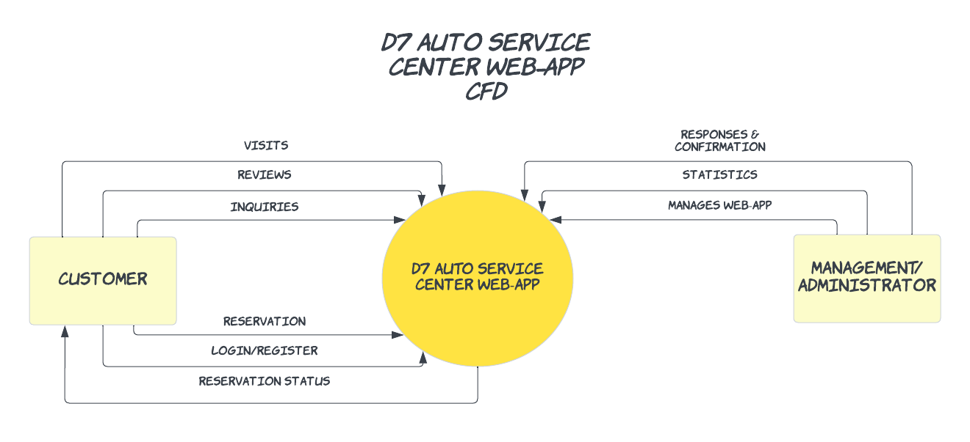

Figure 3 Context Flow Diagram

### Data Flow Diagrams

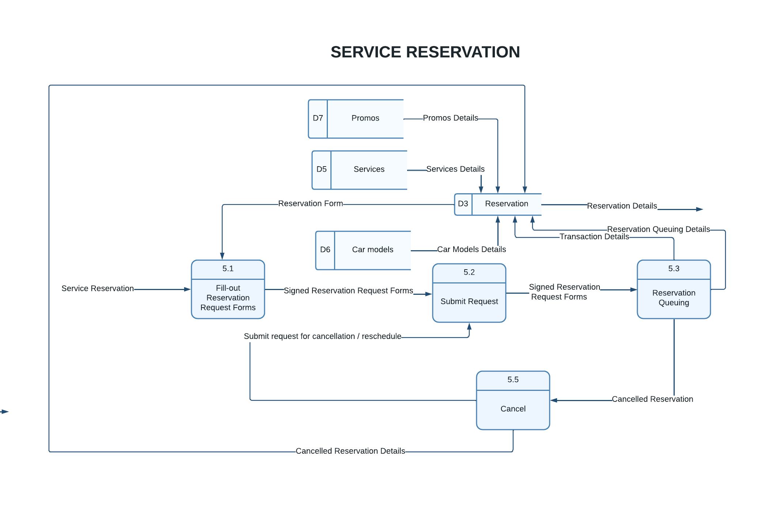

Figure 4 Data Flow Diagram: Service Reservation

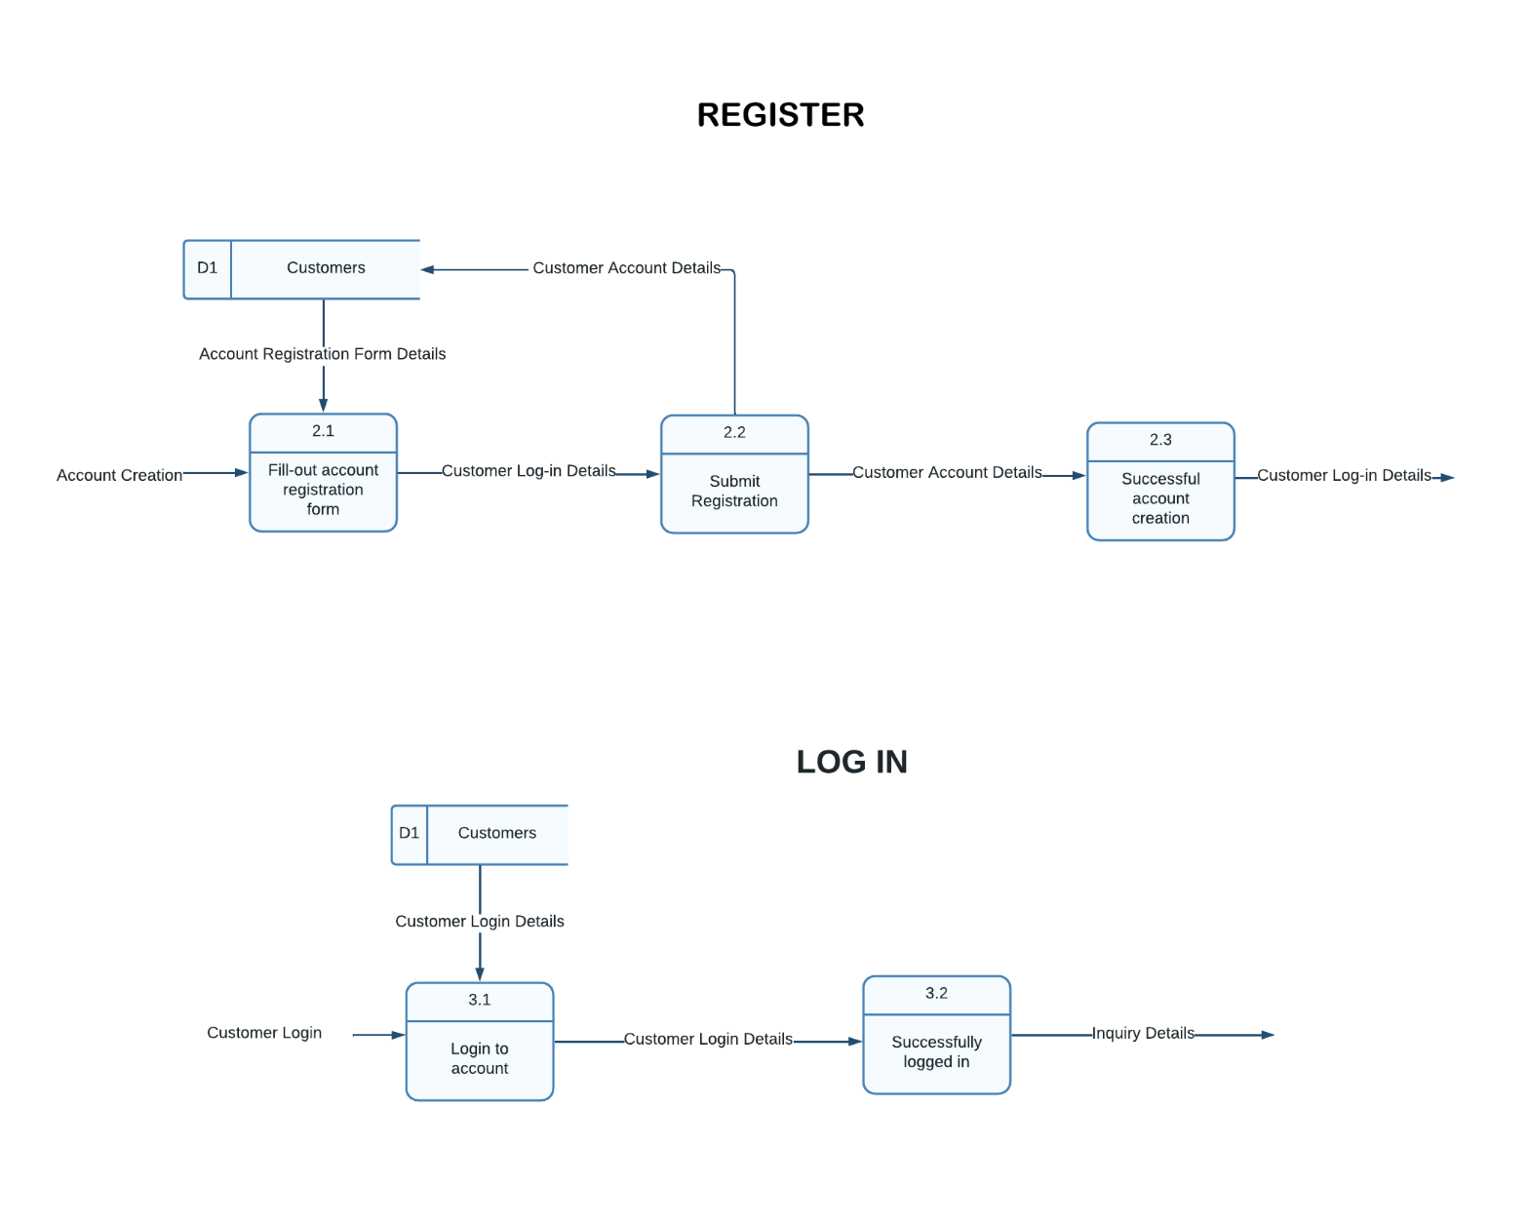

Figure 5 Data Flow Diagram: Account Creation

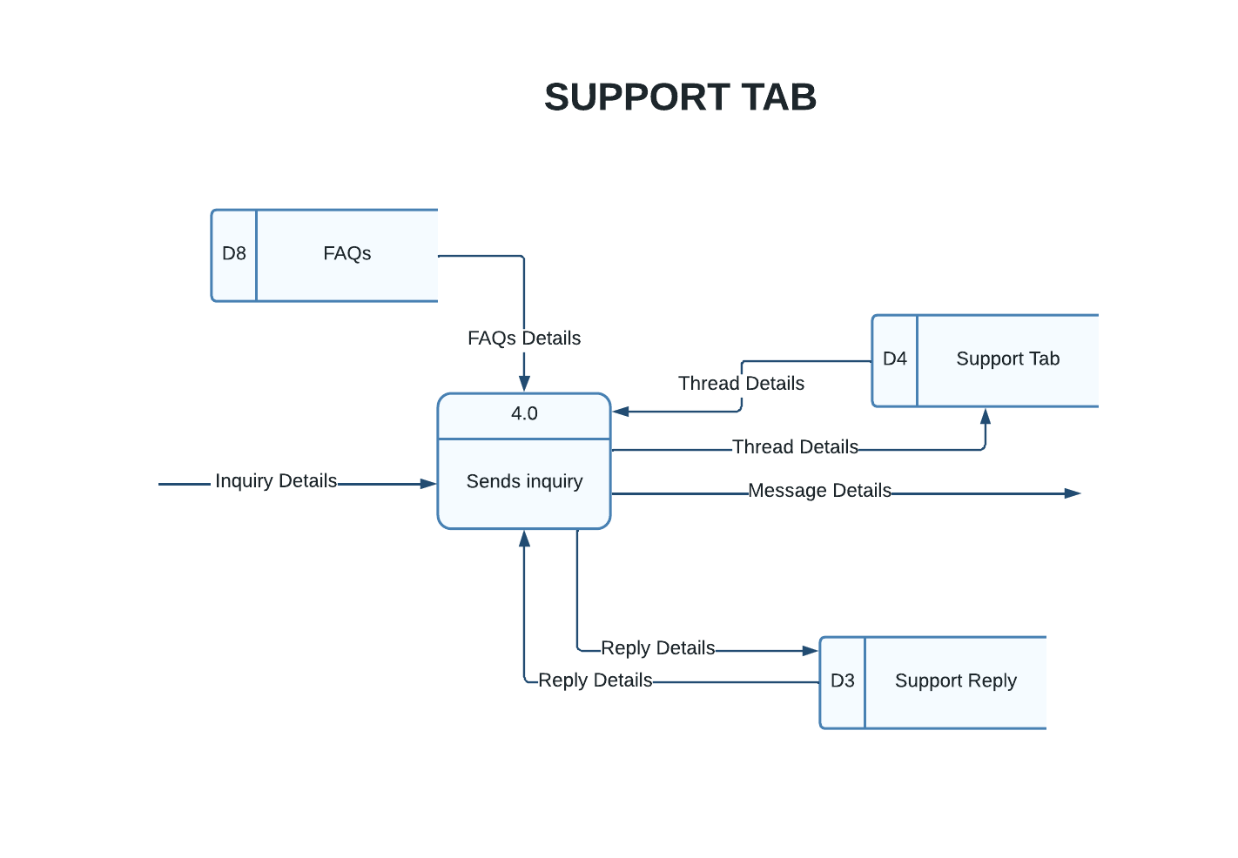

Figure 6 Data Flow Diagram: Support Tab

### Entity-Relationship Diagrams

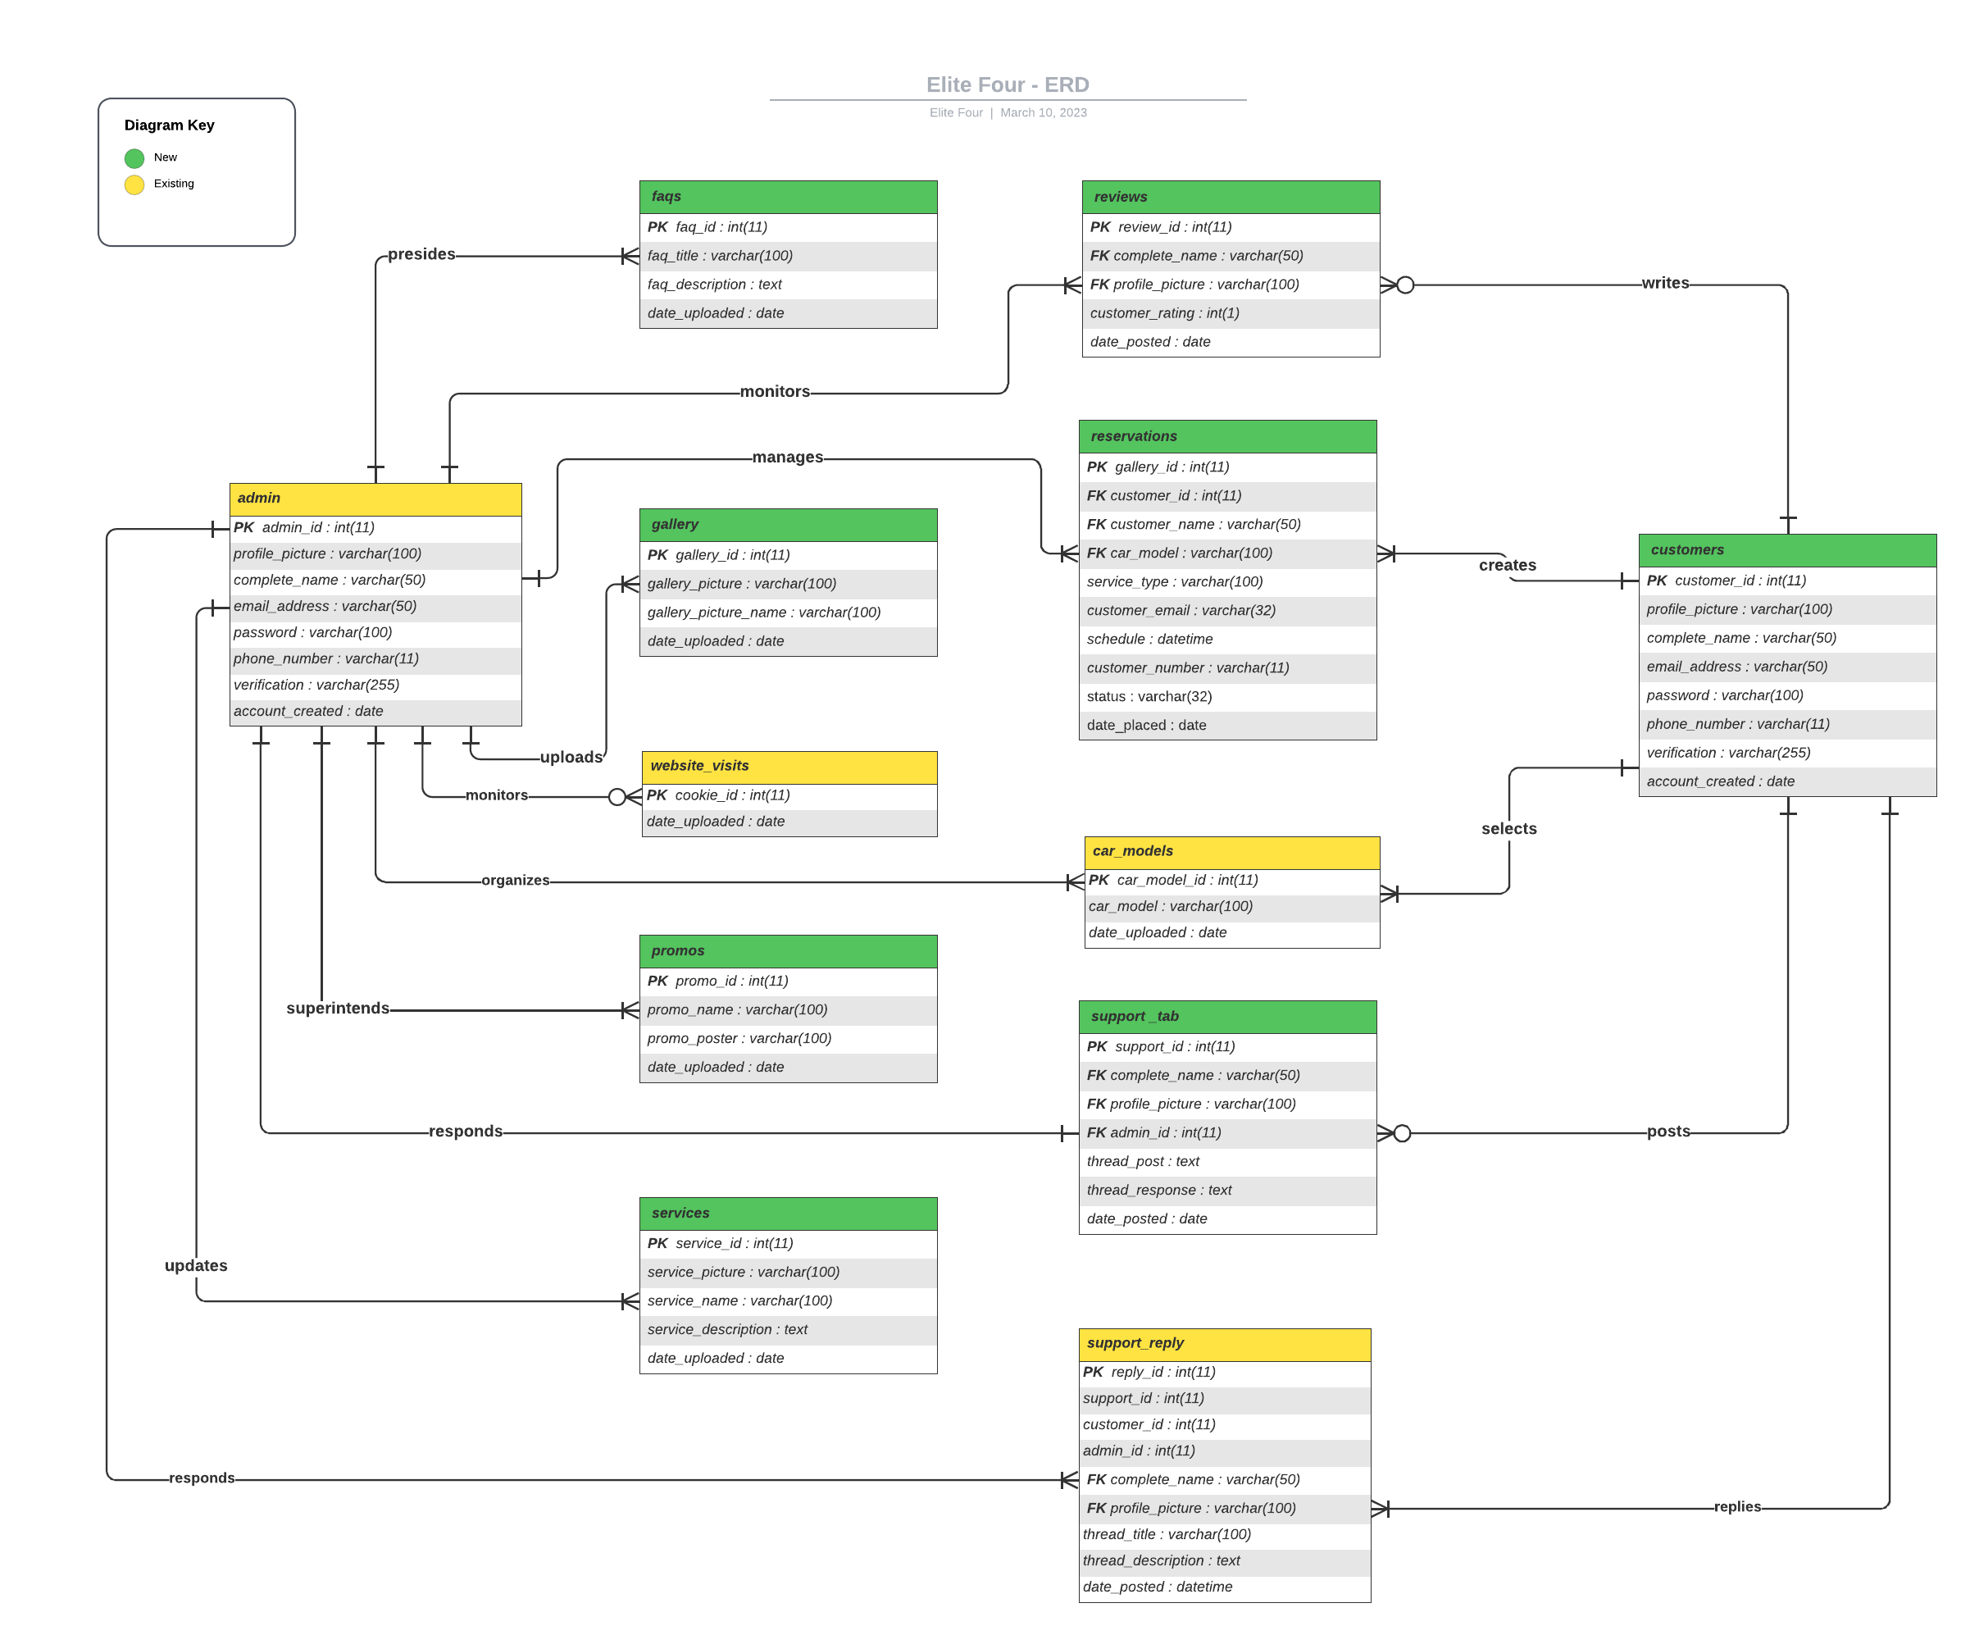

Figure 7 Entity-Relationship Diagram

### Activity Diagram

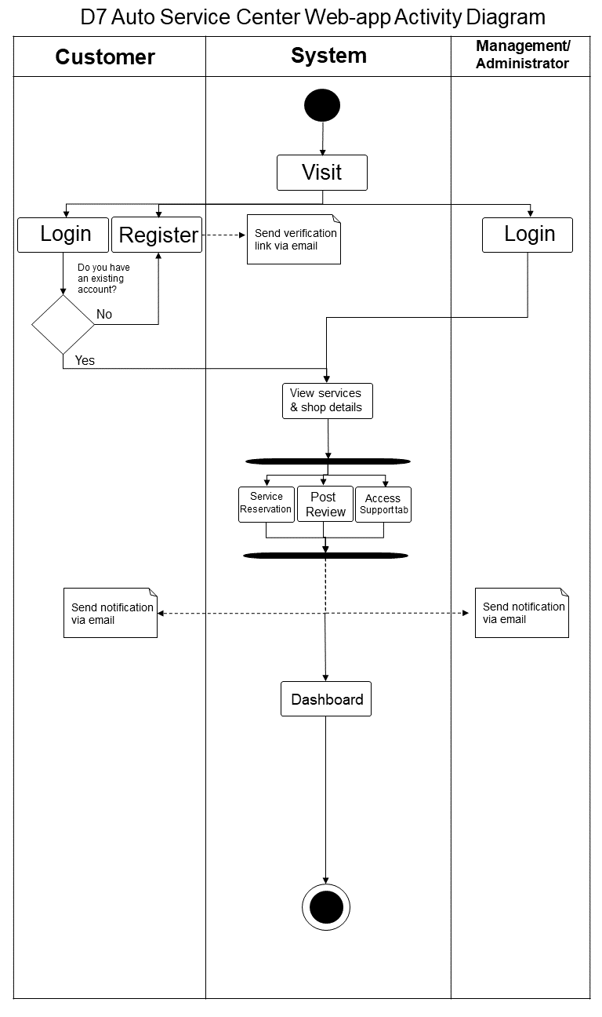

Figure 8 Activity Diagram

### Object Diagrams

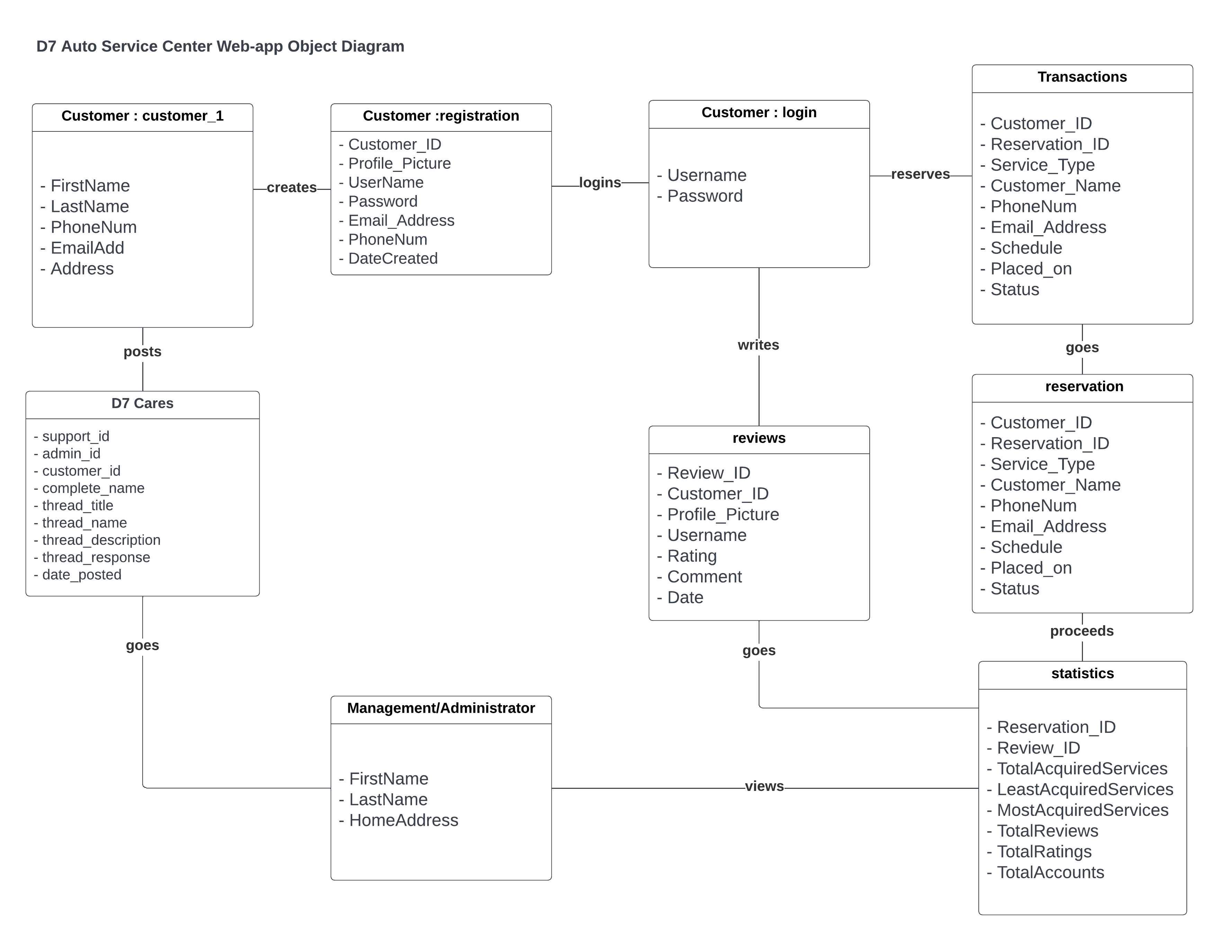

Figure 9 Object Diagram

### Class Diagrams

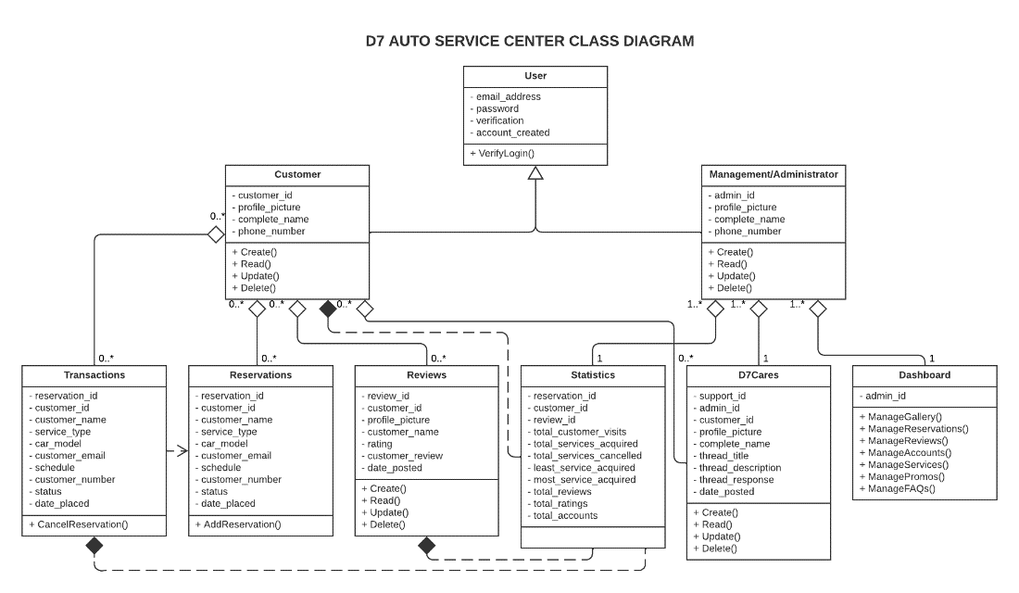

Figure 10 Class Diagram

### Sequence Diagrams

Figure 11 Sequence Diagram: Register & Login

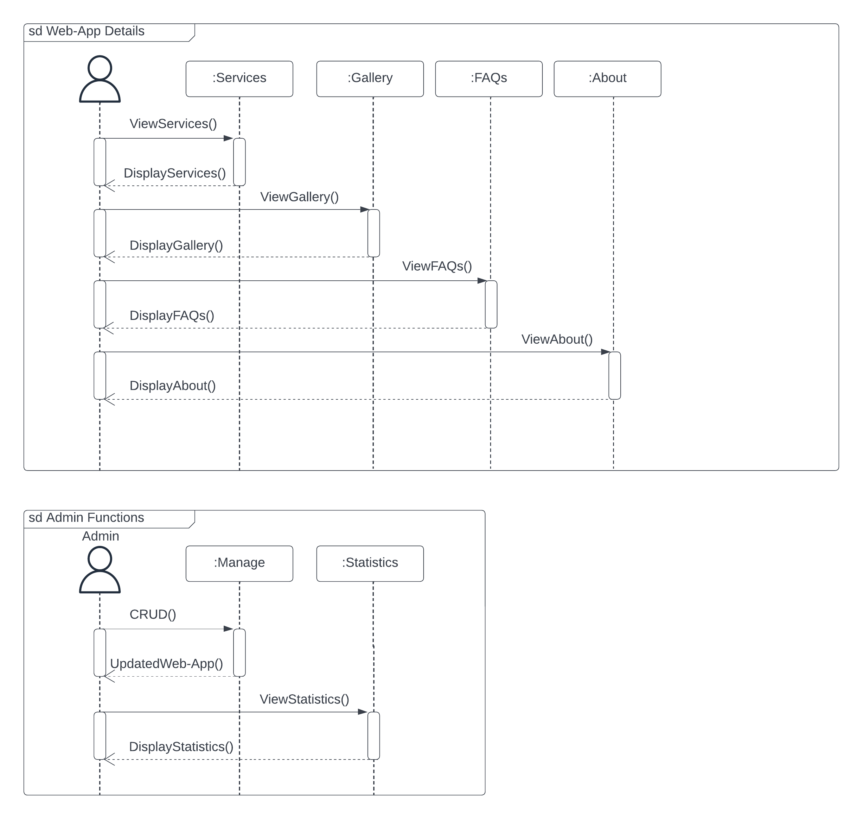

Figure 12 Sequence Diagram: Admin Functions

Figure 13 Sequence Diagram: Reservation

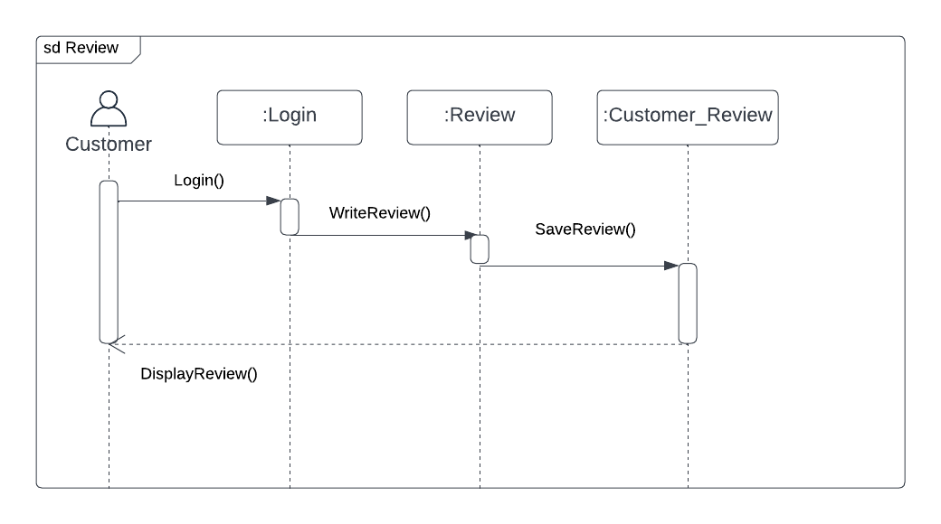

Figure 14 Sequence Diagram: Review

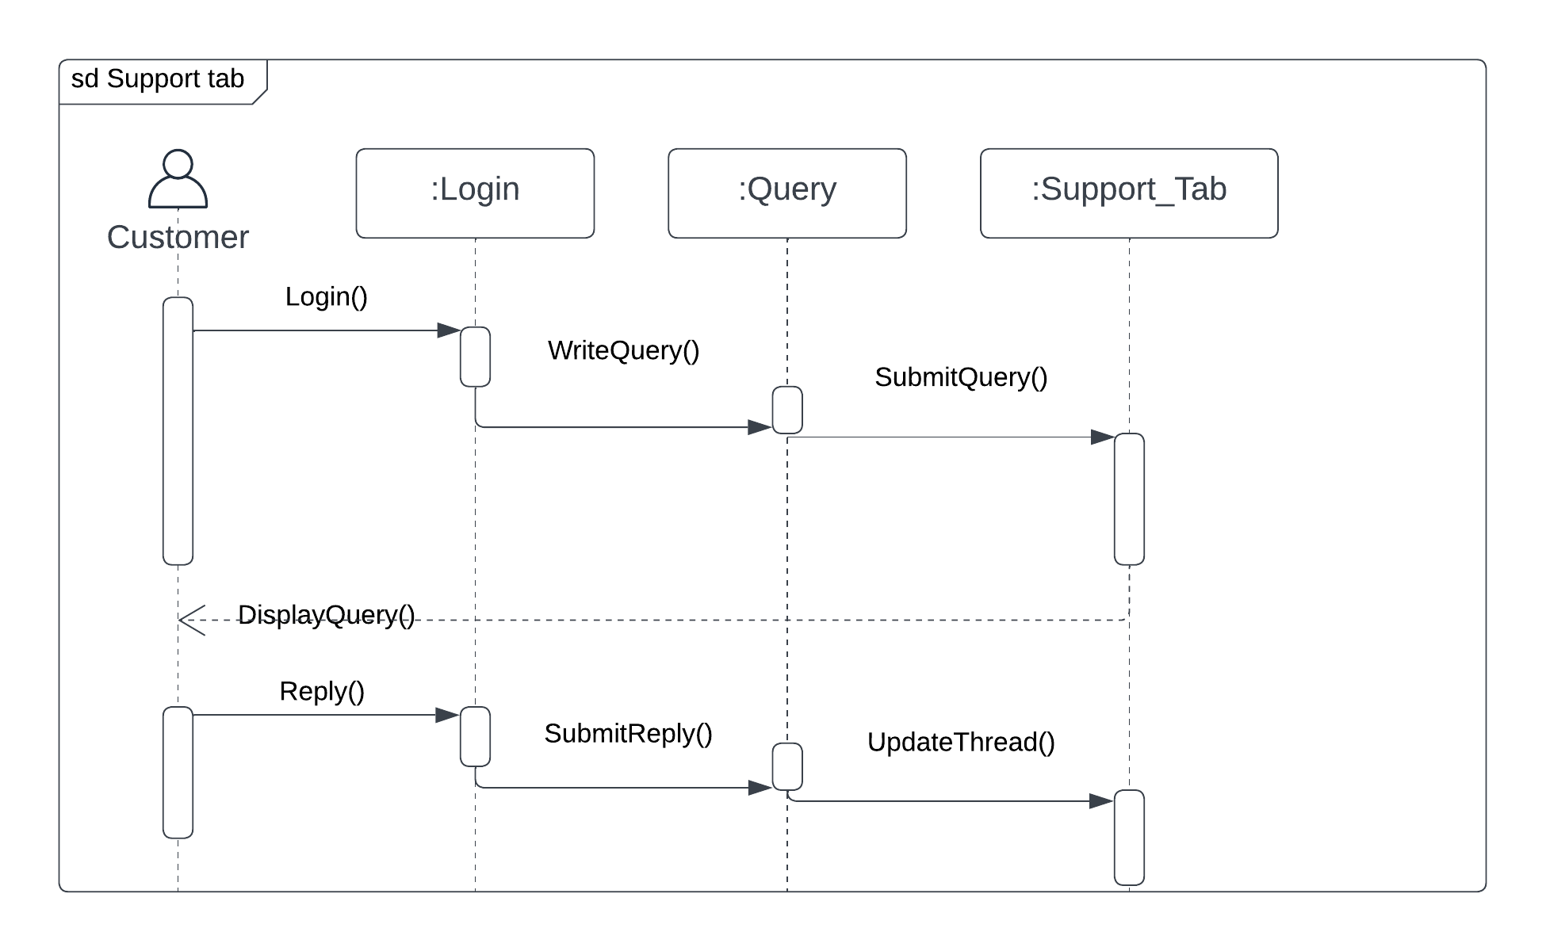

Figure 15 Sequence Diagram: Support Tab

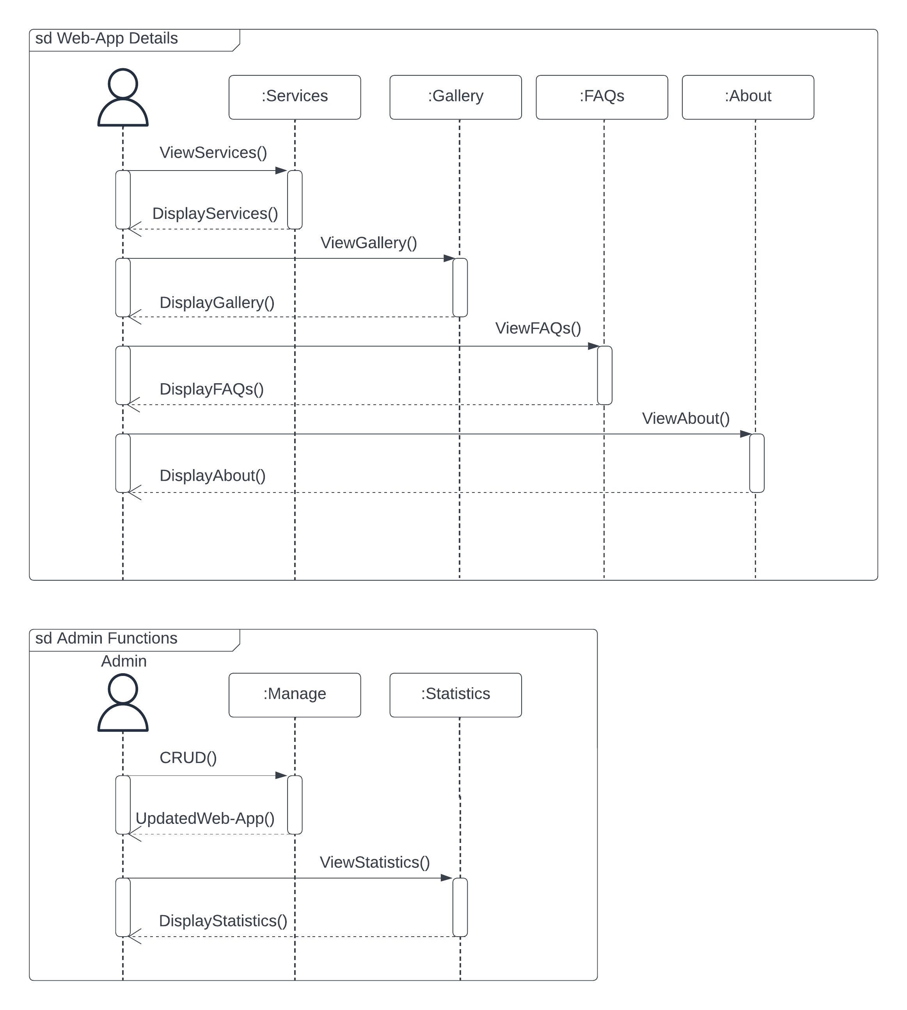

Figure 16 Sequence Diagram: View Web-App Details

### Package Diagram

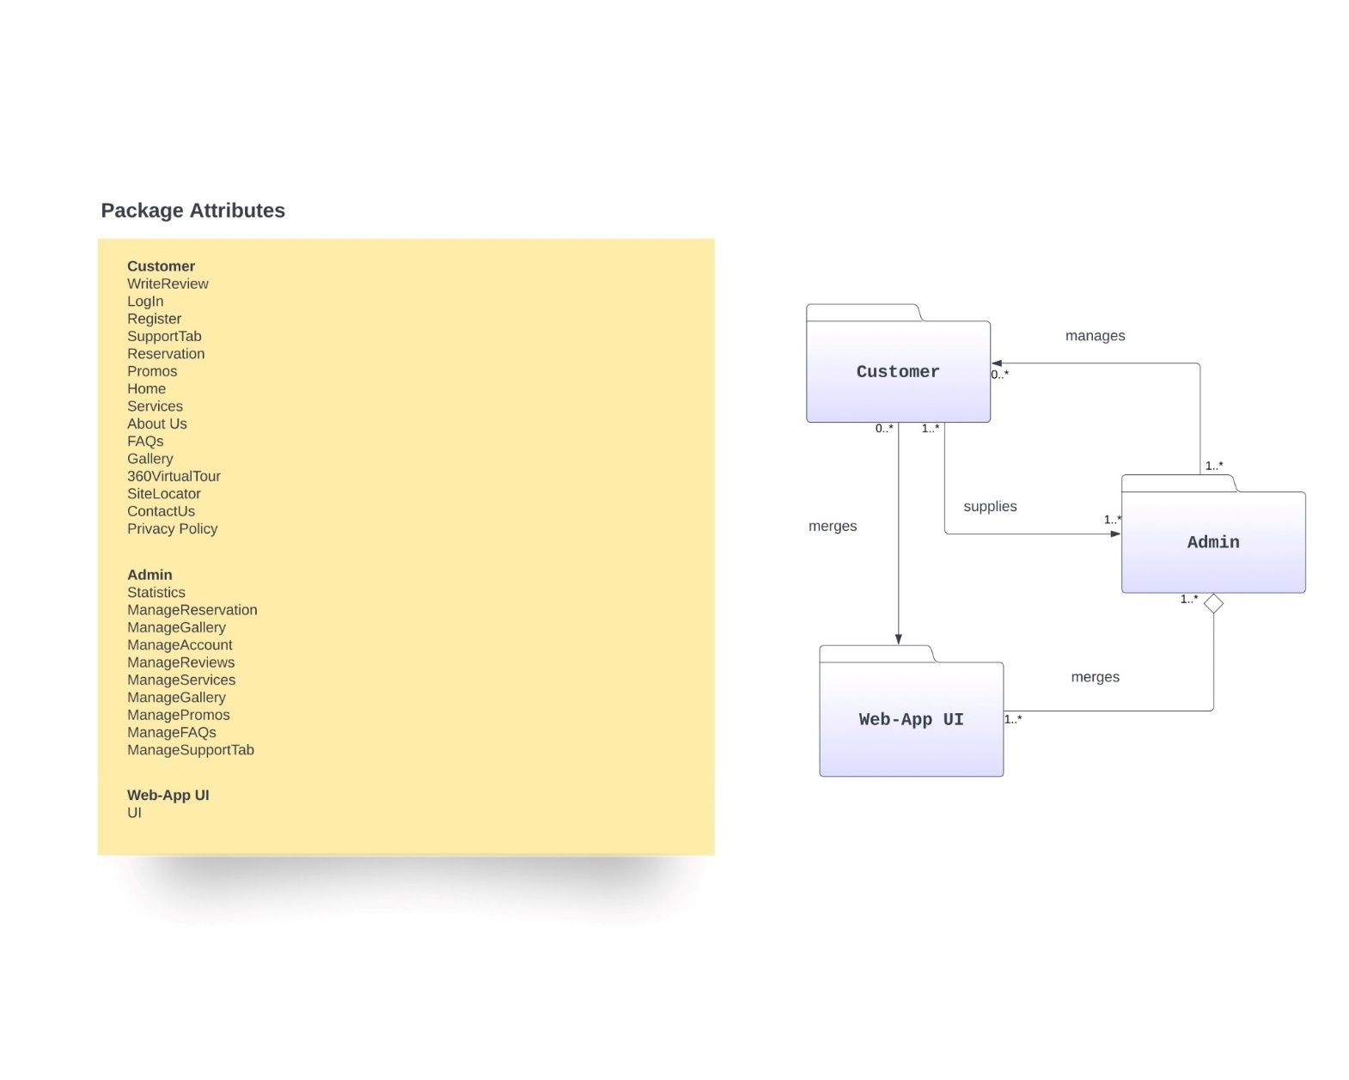

Figure 17 Package Diagram

### Component Diagram

Figure 18 Component Diagram

### Deployment Diagram

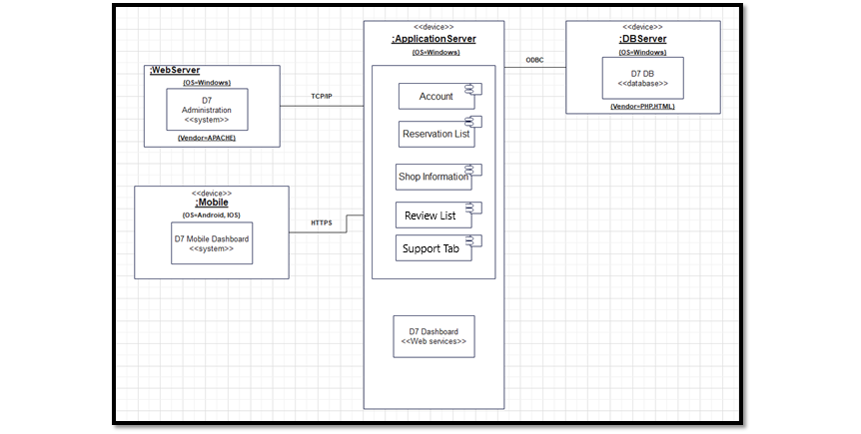

Figure 19 Deployment Diagram

### 4.3.11 State Machine Diagram

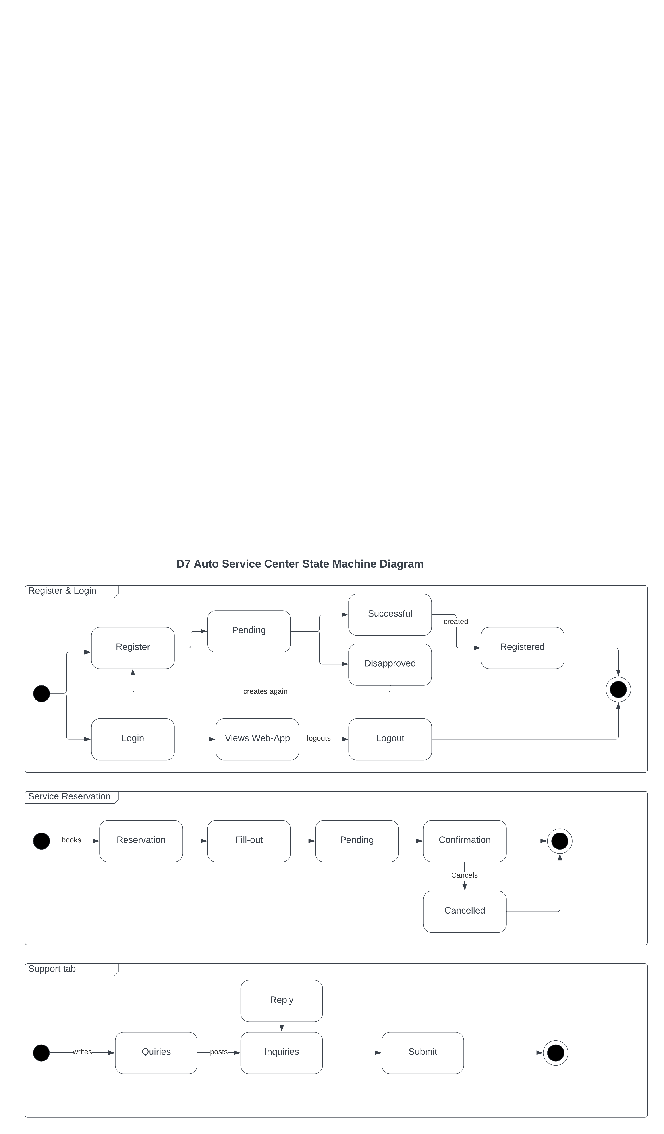

Figure 20 State Machine Diagram: Register & Login, Support Tab, and Service Reservation

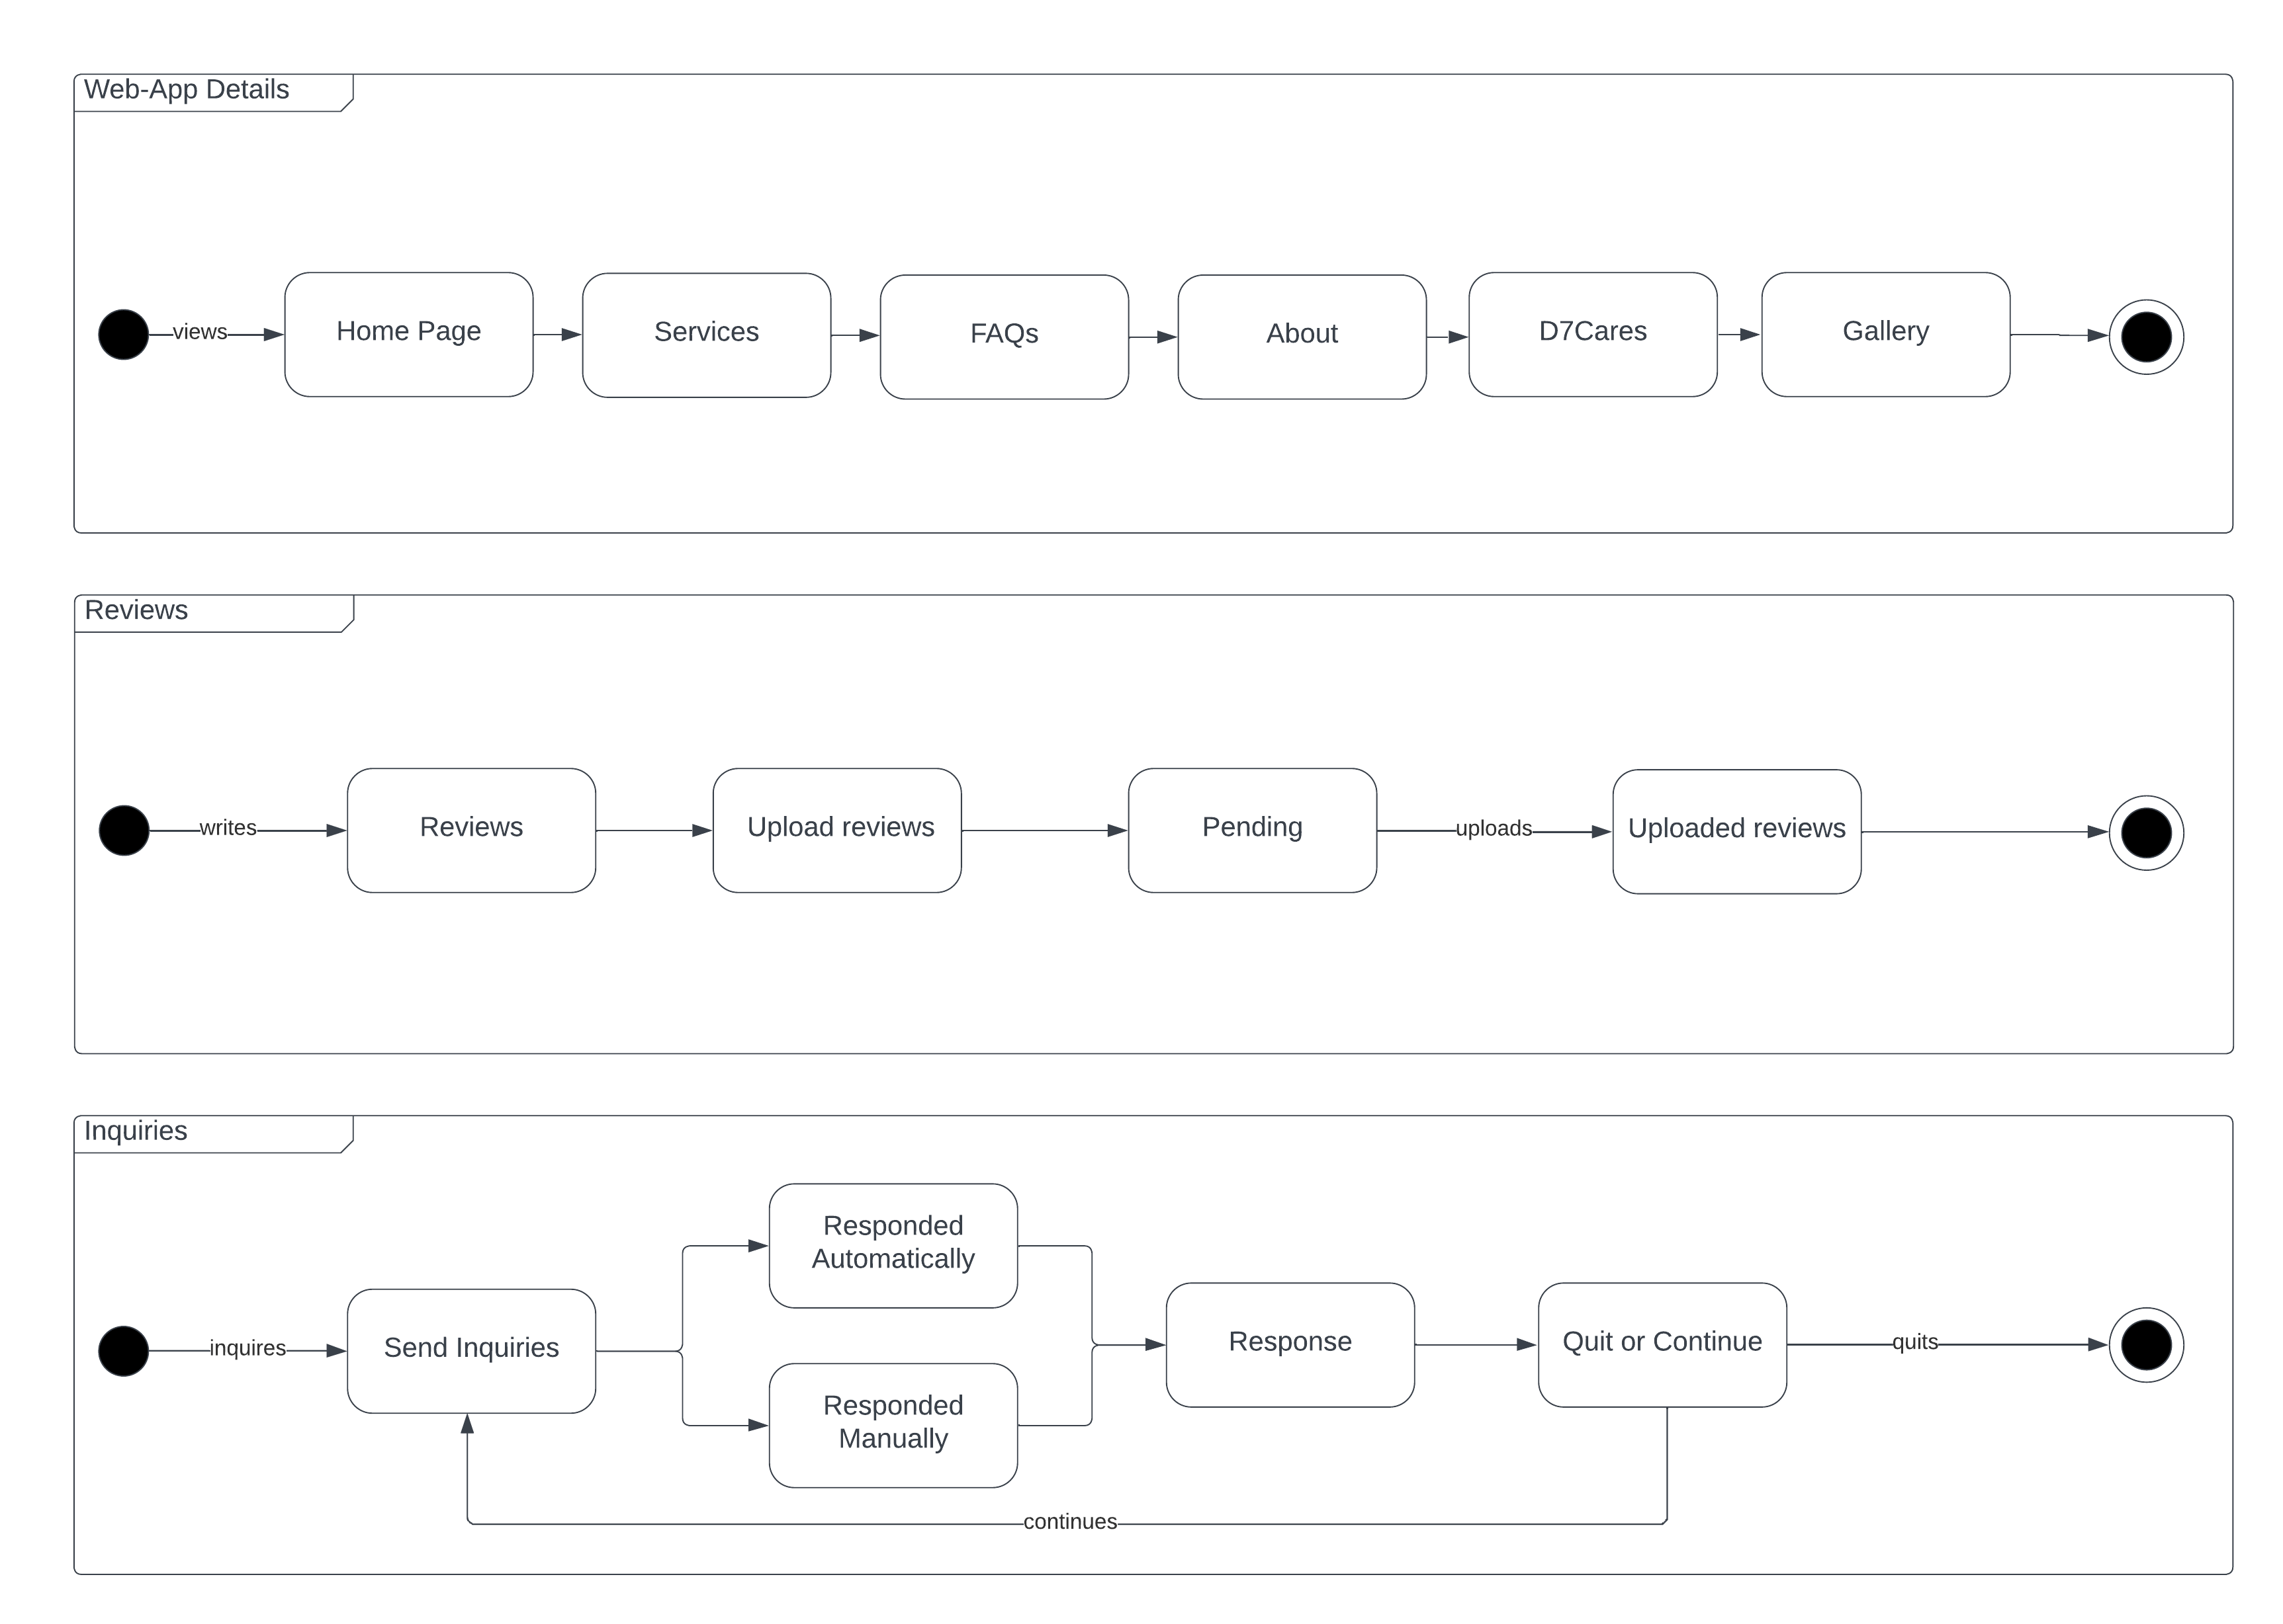

Figure 21 State Machine Diagram: Reviews & Shop Details

# Results and Discussion

This section will discuss the release plan of the team for the web-app as well as the prototype that will be used as reference to develop the web-app. This section will also supply use classes and characteristics to show the roles of the users inside the system.

# 5.1 Release Plan

The following table is the proposed release plan of the team. It is to prioritize the customer side of the system to enable smooth flow of interactions and visits of the customer with little to no errors. After polishing the client of the system, the team will continue to develop the admin side of the system. In line with this the team has not yet started the development of the web-app.

Table 14 Release Plan

|  |  |  |
| --- | --- | --- |
| Release Plan 1 | Release Plan 2 | Release Plan 3 |
| Login System  - CRUD Operations  Web-App Details  - Home  - Services  - Promos  - Gallery  - FAQs  - About Us  - Social Media Button  - Site Locator  - Contact Us  - 360 Virtual Tour | **Reservation System**  - CRUD Operations  **Dashboard**  - Manage Accounts  - Manage Reservations  - Manage Services  - Manage Gallery  - Manage Promos  - Manage Reviews  - Manage FAQs  **Review System**  - CRUD Operations | **Support Tab**  - CRUD Operations  **Statistics**  - Statistics Reports |

## 5.2 Prototype

Figure 22 Sign Up

This prompt allows the customers to sign up.

Figure 23 Login

This prompt allows the customer to login to the web-app to access the features that require an account.

Figure 24 Customer Profile

This prompt allows the customers to Delete Account, View Transaction History, Change Password and Update their Customer Profile.

Figure 25 Transaction History

This section allows the customer to view their transaction and cancel their reservation.

Figure 26 Home Page

This section displays some of the services available and the 360 virtual tours of the D7 Auto Service Center.

Figure 27 Services

This section is where the customer can view all the available services in detail.

Figure 28 Gallery

This section allows the administrator/management upload photos of the serviced vehicles, for customers to see that there are a lot of customers that come by to avail themselves of their services.

Figure 29 Reviews

This section displays the fair share of experiences from the past customers of D7 Auto Service Center.

Figure 30 FAQs

This section will help the customer to have an immediate response to questions that clients may have.

Figure 31 About Us

This section allows the customers to view the outstanding history of D7, together with their specialists.

Figure 32 Reservation Form

This section allows the customers to make a reservation and to pay the base price of the acquired services.

Figure 33 D7Cares

This section allows engagement with D7 specialist and their customers.

Figure 34 Dashboard

This section allows the management/administrator to view the statistics, reservation list, and manage the web-app.

## 5.3 Use Classes and Characteristics

Table 15 Use Classes and Characteristics

|  |  |  |
| --- | --- | --- |
| Roles | | Description |
| Management/Administrator | | A type of user that can Create, Read, Update, and Delete content in the entire web-app |
| Customer | A type of user that can view the content of the web-app, create an account, login to the website to be able to make a reservation, and write a review. | |

# Conclusion

With the given time for the MCSPROJ term, the team’s progress includes making the progress of the web application that has been checked by the team’s project adviser, project consultant, and with the approval of the team’s instructor. The team was able to do the following in response to the aims:

* Creation of prototype and UI
* Creation of Database
* Finalization of Paper

During the finals of the MCSPROJ, the team was able to develop a 100% working web-app ready for deployment for D7 Auto Service Center. As for the upcoming phase of PBL which is PROJMAN, the team will still continue the project, and may possibly improve its features as the PROJMAN phase comes by.

# References

|  |  |
| --- | --- |
| [1] | S. Thimothy, "5 Reasons why Facebook is bad for small businesses," *Click X.* |
| [2] | Awesome, "Website vs Social Media: What's the difference and do I need both?," *Awesome,* 2020. |
| [3] | J. Clabaugh, "Your business’ social media isn’t enough. You really still need a website," *Wtop News,* 2019. |
| [4] | H. A. Malak, "9 Records Management Challenges and How to Overcome Them," 2023. |
| [5] | T. Soulo, "How long does it take to rank in Google? (A study by Ahrefs)," 17 February 2017. [Online]. Available: https://ahrefs.com/blog/how-long-does-it-take-to-rank/. [Accessed March 2023]. |
| [6] | gosite, "5 Reasons Your Business Needs a Reservation System," 24 June 2020. [Online]. Available: https://www.gosite.com/blog/5-reasons-your-business-needs-a-reservation-system#:~:text=An%20online%20reservation%20system%20allows,new%20customers%20to%20make%20appointments. [Accessed 2023]. |
| [7] | T. Ehsan, "Why Website is Important For a Business," Linkedin, 2021. |
| [8] | S. Jordan, "76% of Consumers Look at Online Presence Before Physically Visiting a Business," *Cision,* 2021. |
| [9] | December Communications Inc., "Innovate," *December Communications Inc.,* 2022. |
| [10] | Harford, "Do You Really Need a Website?," *The Hartford,* 2022. |
| [11] | A. Reshard, "Developing a website for online consumers to find foreign businesses in Finland," 2021. [Online]. Available: https://www.theseus.fi/bitstream/handle/10024/511595/Reshard_Alexandria.pdf?sequence=2&isAllowed=y. [Accessed 27 April 2022]. |
| [12] | Yellow Bird Auto Center, "Yellow Bird Auto Center," Yellow Bird Auto Center, [Online]. Available: https://www.yellowbird-autocenter.com/. [Accessed 2 June 2022]. |
| [13] | Pioneer Auto Repair shop, "Pioneer Auto Repair shop," Pioneer Auto Repair shop, [Online]. Available: https://www.pioneerautobody.net/. [Accessed 2 June 2022]. |
| [14] | Galson Auto Body, "Galson Auto Body," Galson Auto Body, [Online]. Available: https://www.galsonauto.com/. [Accessed 2 June 2022]. |
| [15] | "Rapide Auto Service Experts," [Online]. Available: https://rapide.ph/. [Accessed 23 June 2022]. |
| [16] | "Centinnial Auto Services, Inc.," [Online]. Available: http://centennialauto.ph/#. [Accessed 23 June 2022]. |
| [17] | "MechaniGo.Ph," [Online]. Available: https://mechanigo.ph/about. [Accessed 23 June 2022]. |
| [18] | B. Clark, "How much does a website increase sales?," *Acquire,* 2022. |
| [19] | A. Khlystova, "5 Benefits of Live Chat for Your Business (Infographic)," *Help Crunch,* 2022. |
| [20] | C. Campbell, "New Study Highlights the Importance of Online Reviews in Local Search," *Social Media Today,* 2017. |
| [21] | Visual Studio Code, "Why did we build Visual Studio Code?," Visual Studio Code, 1 September 2022. [Online]. Available: https://code.visualstudio.com/docs/editor/whyvscode. [Accessed September 2022]. |
| [22] | PHP, "What is PHP?," PHP, [Online]. Available: https://www.php.net/manual/en/intro-whatis.php. [Accessed September 2022]. |
| [23] | Java T point, "Xampp tutorial," Java T point, [Online]. Available: https://www.javatpoint.com/xampp. [Accessed September 2022]. |
| [24] | MySQL, "What is MySQL?," MySQL, [Online]. Available: https://dev.mysql.com/doc/refman/8.0/en/what-is-mysql.html. [Accessed September 2022]. |
| [25] | wpbeginner, "What is: Apache," wpbeginner, [Online]. Available: https://www.wpbeginner.com/glossary/apache/. [Accessed September 2022]. |
| [26] | w3schools, "HTML Introduction," w3schools, [Online]. Available: https://www.w3schools.com/html/html_intro.asp. [Accessed September 2022]. |
| [27] | w3schools, "CSS Introduction," w3schools, [Online]. Available: https://www.w3schools.com/css/css_intro.asp. [Accessed September 2022]. |
| [28] | Kinsta, "What Is GitHub? A Beginner’s Introduction to GitHub," Kinsta, 16 September 2022. [Online]. Available: https://kinsta.com/knowledgebase/what-is-github/. [Accessed September 2022]. |
| [29] | w3schools, "What is Bootstrap?," w3schools, [Online]. Available: https://www.w3schools.com/whatis/whatis_bootstrap.asp. |
| [30] | K. Casey, "Everything you need to know about Scrum Methodology," 28 December 2021. [Online]. Available: https://codersera.com/blog/what-is-scrum-methodology/. |
| [31] | Revfine, "Why is an Integrated Online Booking System Important?," *Revfine.* |
| [32] | A. Davies, "What is Agile Methodology?," DevTeam.Space, [Online]. Available: https://www.devteam.space/blog/what-is-an-agile-methodology/. [Accessed 25 September 2022]. |
| [33] | D. Collard, "How Much Does a Website Increase Sales For Your Business?," eposnow, 3 May 2022. [Online]. Available: https://www.eposnow.com/us/resources/how-much-does-a-website-increase-sales-for-your-business/#:~:text=An%20online%20business%20never%20closes,enterprises%20that%20aren't%20online.). [Accessed March 2023]. |

# Appendices

## Appendix A: Project Vision

**For** D7 Auto Service Center’s Marketing Team,

**Who** aims to have a platform that will help them resolve their struggles in their current system and be able to advertise their services, and their Service Center.

**The** D7 Auto Service Center Web-App is a web application project.

**That** aims to give D7 an added platform that helps them advertise their services offered, while it also adds online presence for the company. This project also aims to have an online reservation, generated monthly reports of the number of people that got the services, number of accounts registered, which services were least, and most acquired, and overall ratings and number of reviews. The project also aims to utilize statistics using the monthly reports, to evaluate the business' performance as a basis for better decision making.

**Unlike** the competitors of D7 where most of them use Facebook as a marketing platform for their service, they struggle not only with making their establishment stand-out.

**Our Product** offersthe basic features to cater D7’s needs such as *review/feedback section, social media buttons as links, Gallery, Site Locator, About Us, Promos and Services, mobile optimization,* while it also offers innovative features such an online *reservation system, customer and admin login, 360 virtual tour of the establishment, Supports Tab, monthly reports of acquired services through a dashboard that shows: which services were least, and most acquired, total customer review ratings, total customer reviews, and statistics to help the business evaluate its performance for better decision-making.*

## Appendix B: Schedule

Table 16 Schedule

|  |  |
| --- | --- |
| Week | Learning Deliverables |
| 01 | 1. The team was assigned to transfer the MNTSDEV final set of requirements to a new project channel in MSYADD1. 2. After creating the channel, the team was assigned to dump all the files into the new project channel. 3. The team was assigned to select a project adviser and consultant/s. 4. The team was assigned to secure the signature of the project adviser and consultant/s by filling in the proper forms. |
| 02 | 1. The team was assigned to create an MVC infographic that illustrates the MVC framework and to supply an example derived from the project. 2. The team was assigned to put all the information on one ppt slide, describing how the MVC works. 3. After finishing the MVC, they were assigned to upload it to the group project channel and in the GitHub project repository, |
| 03 | 1. The team was assigned to create an event table for the existing process of D7 Auto Service Center |
| 04 | 1. The team was assigned to create an event table for the existing process of D7 Auto Service Center. 2. The team was assigned to create a Data Flow Diagram. 3. The team was assigned to create a Use Case Diagram. 4. The team was assigned to create an ERD. |
| 05 | 1. Existing Diagrams of the D7 Auto Service Center:  * Object Diagram * Activity Diagram  1. Proposed Diagram of the D7 Auto Service Center:  * Event table * Context Flow Diagram (CFD) * Use Case Diagram (UCD) * Use Case full description * Data Flow Diagram (DFD) * Entity Relationship Diagram (ERD) Level 0 & Level 1 |
| 06 | 1. The team was assigned to update and complete our midterm paper: 2. Introduction 3. Review of Related Literature and Systems 4. Technical Background 5. Methodology (from 4.1 to 4.3.6) 6. The team was assigned to update our proposal video 7. The team was assigned to update our Comment Matrix 8. The team was assigned to update our presentation deck |
| 07 | 1. The team was assigned to present the midterm project presentation. 2. The team was assigned to present the MNTSDEV panelists’ comments and updates made by the group to address the suggestions. |
| 08 | The team was assigned and carried out to study the following diagrams:   * Sequence Diagram * State Machine/ Transition Diagram * Package Diagram * Deployment Diagram * Component Diagram |
| 09 | The team was assigned to create the following diagrams:   * Sequence Diagram * State Machine/ Transition Diagram * Package Diagram * Deployment Diagram * Component Diagram * Finalized ERD * Data Dictionary |
| 10 | 1. The team was assigned to create the draft of presentation and videos  2. The team was assigned to create:   * Quality review of diagrams * Interface designs * Initial code review of prototype |
| 11 | 1. The team was assigned to create the sprint 3 output:  * Updated Wiki and GitHub * Pre-final presentation with project adviser * Project adviser endorsement for final presentation * Project adviser project group evaluation |
| 12 | 1. The team was assigned to create the sprint 4 output:  * Final paper * GitHub repository * Project video teaser * Ppt project presentation  1. The team was assigned to create an announcement in our respective channels and use the title Final Set of Requirements. Include the following files or links to the following:  * Final Paper (updated using panelists suggestions) * Comments Matrix * GitHub repository * Project video teaser * Ppt project presentation  1. The team was assigned to email the panelist a day before the scheduled defense:  * Final paper * Project video teaser * Ppt project presentation * Comments matrix * Finals rubric |
| 13 | The team was assigned to create the following after panelist approval:   * + 1. Updated final paper     2. Comments Matrix |

## Appendix C: Product Roadmap

Table 17 Product Roadmap

|  |  |  |
| --- | --- | --- |
| MNTSDEV | MSYADD1 | MSCPROJ |
| * Meeting with the client to plan the features to be included in the web-app. * Visualizing the UI/UX design * Creating prototype of the Web-app * Planning schedules | * Finalizing the features of the Web-app * Finalizing the UI/UX design * Decide what software to use to make the Web-app. * Proceeding to Release Plan 1, creation of the following features:   + Login System   + Web-App Details * Release Plan 1 features testing | * Proceeding to creation of Release Plan 2’s features:   + Review System   + Reservation System   + Manage Web-app. * Release Plan 2 features testing * Proceeding to creation of Release Plan 3’s features:   + Statistics * Release Plan 3 features testing * Finalization with the client * Deployment of the Web-app |

## Appendix D: Data Dictionary

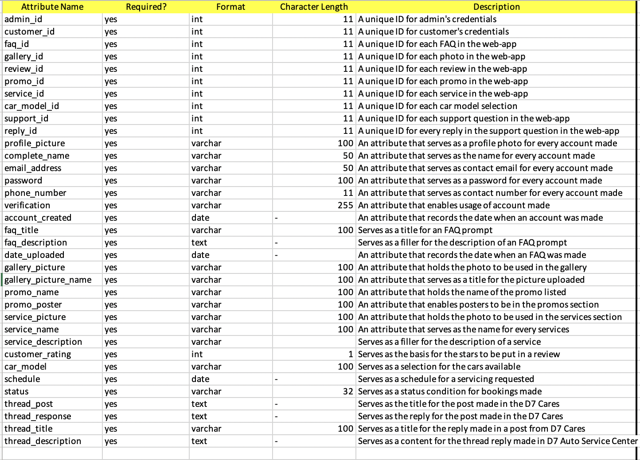

Figure 35 Data Dictionary

## Appendix E: User’s Manual

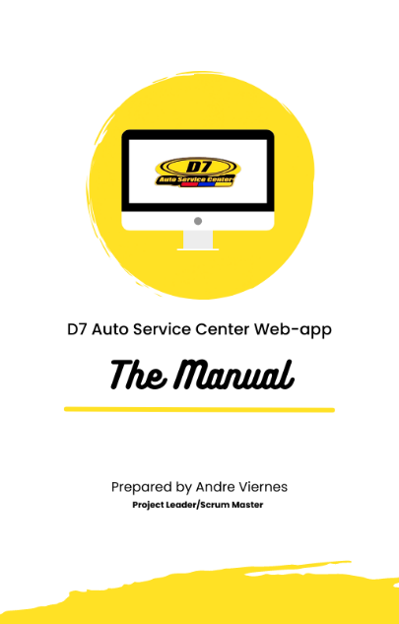

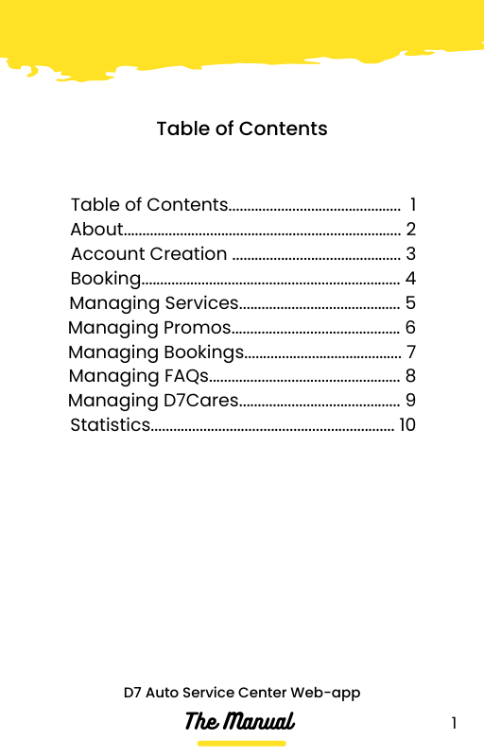

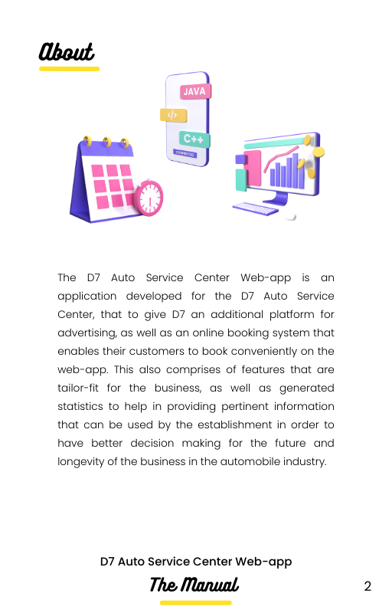

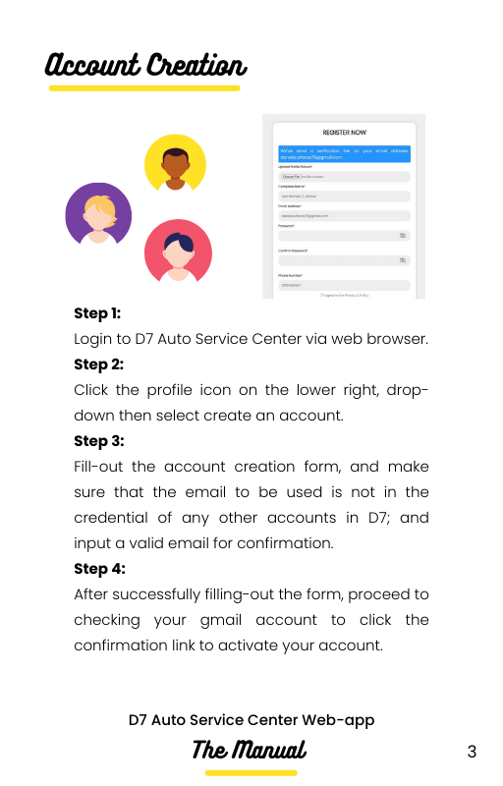

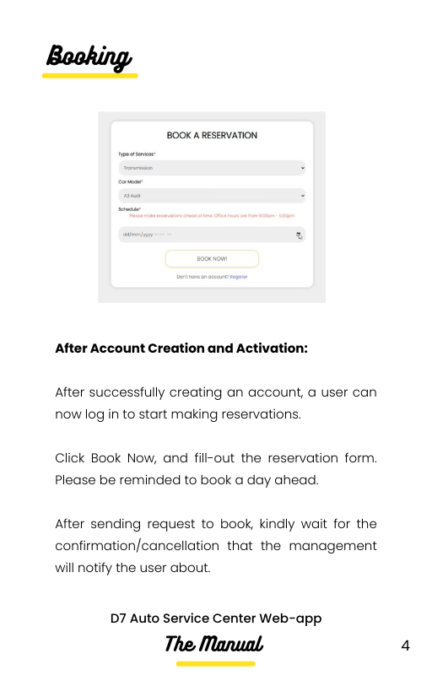

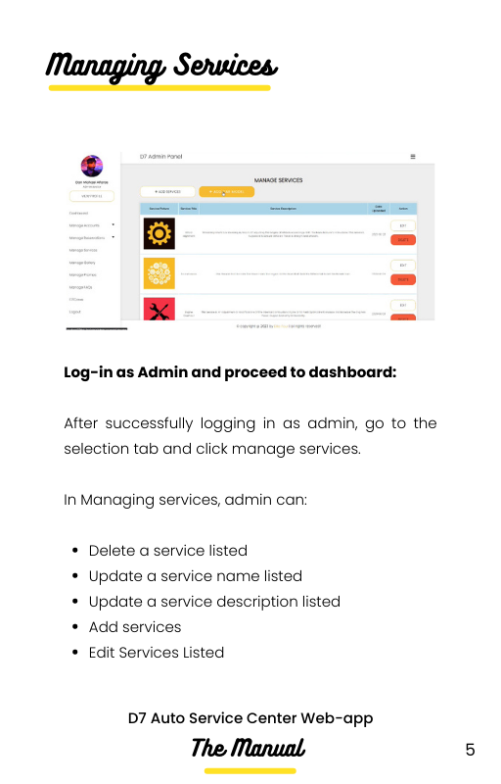

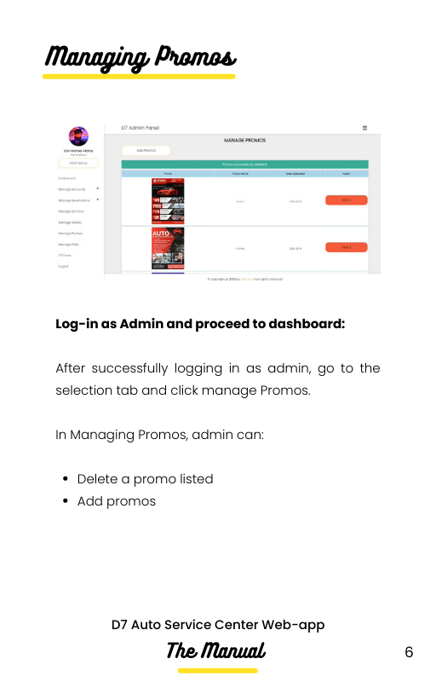

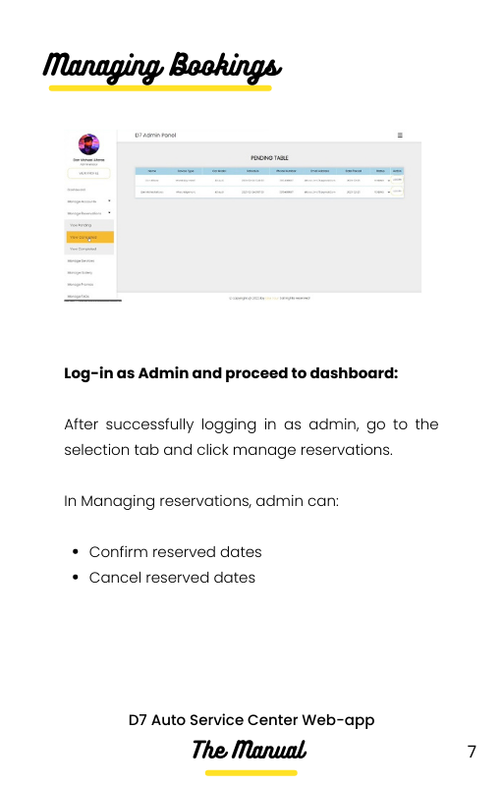

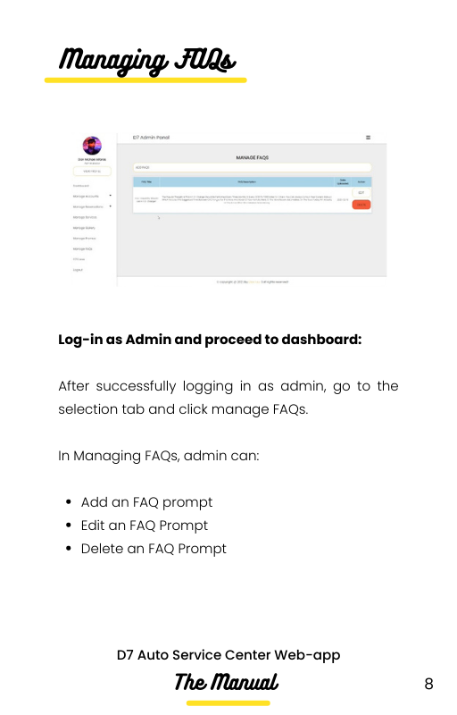

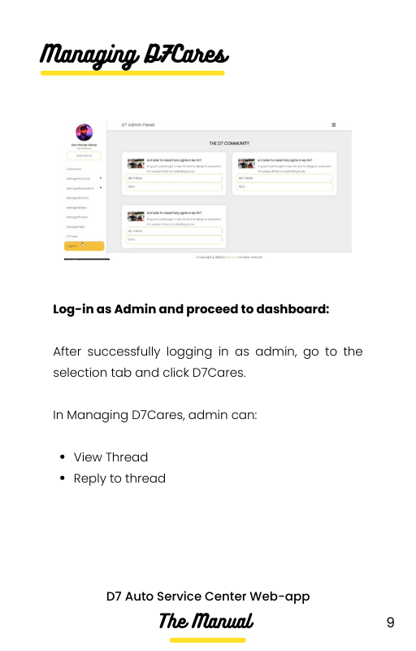

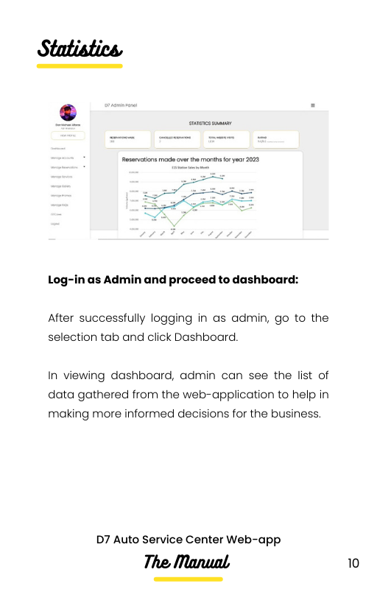

## Appendix F: Team Meetings

**Midterms**

Creation of MVC | 1:00:00 hour | August 28, 2022

* 3:40 – Brainstorming of the content.
* 7:09– Searching for a similar MVC model.
* 16:34 – Collecting sources to use.
* 32:04 – Brainstorming how sources can be used
* 45:07 – Starting to create the MVC
* 56:20 – Finishing the MVC model

Creation of existing Event Table | 1:56:00 hour | August 30, 2022

* 4:02 – Brainstorming what is event table.
* 5:07 – Creating a word document.
* 7:18 – Disseminating the task.
* 12:09 – Doing the assigned task.
* 22:48 - Gathering information about what is the current system.
* 37:22 – Moving the document to OneDrive
* 39:14 – Checking the contents per row
* 54: 39 – Finalizing the event table

Creation of proposed Event Table | 1:07:00 hour | August 31, 2022

* 4:02 – Brainstorming of what to put in the proposed event table.
* 11:03 – Collecting sources and references to use.
* 13:16 – Creating a word document.
* 18:08 – Disseminating the task per member.
* 25:11 – Doing the assigned task
* 31:02 – Checking the contents per row
* 39:52 – Adding more contents
* 54:48 – Finalizing the event table

Creation of diagrams | 2:19:00 hours | September 5, 2022

* 5:03 – Dissemination of task
* 8:32 – Studying the diagrams.
* 20:17 – Gathering sources and references.
* 45:33 - Doing the assigned task
* 1:59:42 – Checking each diagram.

Creation of diagrams | 1:36:00 hour | September 12, 2022

* 3:53 – Updating the earlier diagrams.
* 16:02 – Studying the other diagrams.
* 21:55 – Updating the event table.
* 47:01 – Dissemination of task for other diagrams
* 58:10 – Collecting sources and references
* 1:03:12 – Studying the assigned diagrams.
* 1:14:20 - Start creating the other diagrams.
* 1:20:05 – Checking the diagrams.

Creation of diagrams | 2:25:00 hours | September 20, 2022

* 3:09 – Disseminating task for new set of diagrams.
* 7:32 – Brainstorming for sprint 2.
* 14:06 - Studying the assigned diagrams.
* 24:15 - Collecting sources and references for diagrams.
* 46: 21 – Start doing the assigned task
* 1:04:02 – Studying the relationship in class diagram.
* 1:23:12 – Checking the diagrams.
* 1:57:08 – Finalization of diagrams

Creation of sprint 2 | 2:50:00 hours | September 21, 2022

* 2:15 – Brainstorming about sprint 2.
* 7:31 – Dissemination of task
* 14:22 – Visiting the last term paper.
* 21:49 – Checking what to update.
* 36:09 - Updating the paper for midterms
* 1:03:21 – Discussion parts of paper
* 1:35:02 – Editing the paper.
* 2:13:19 – Finalization of paper

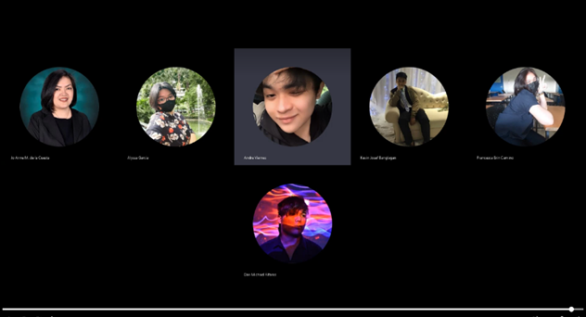

Project Consultation with Project Adviser | 30:41 minutes | September 23, 2022

* 1:00 – Checking of main aim in the paper.
* 1:30 – Rephrasing statements that are more proper in the paper.
* 2:28 – Checking of specific objectives.
* 3:05 – Rephrasing statements per bullets
* 7:50 – Checking of technical background.
* 9:30 – Discussing the implementation of domain.
* 21:59 – Checking of event table.
* 29:35 – Summarization of corrections

Project Consultation with Project Consultant | 24:4 minutes | September 23, 2022

* 1:08– Checking of main objective.
* 1:20 – Removing subjective terms in the main objective.
* 3:15 – Checking the specific objectives.
* 8:47 – Checking of technical background.
* 12:20 - Checking of event table.
* 16:20 – Checking of diagrams.

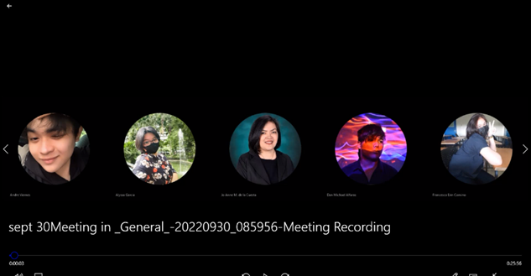

Update with Project Adviser | 25:58 minutes | September 30, 2022

* 1:08 – Consulting about the updated objectives
* 3:54 – Consulting about the updated technical background
* 5:47 – Checking the technicality of the project.
* 9:24 – Rephrasing some statements in the technicality.
* 13:12 – Checking grammar in the technicality.
* 17:49 – Checking the features.
* 19:16 – Checking the updated event table.
* 21:41 – Planning for next meeting.

**Finals**

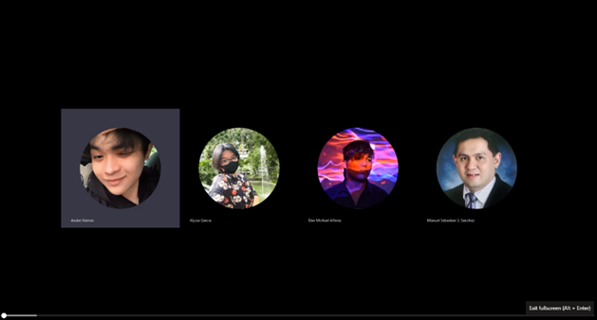

Consultation with Subject Adviser | 26:22 minutes | October 12, 2022

* 1:00 – Checking of sequence diagram.
* 1:12 – The project adviser commented on the sequence diagram.
* 2:21 – Checking of package diagram.
* 3:34 – The project adviser commented on the package diagram.
* 7:28 – The subject adviser giving suggestions to state machine diagram.
* 13:17 – Checking the deployment diagram.
* 15:18 – The project adviser commented on the deployment diagram.
* 21:05 – Rechecking the sequence diagram.
* 22:03 – The project adviser giving further suggestions to state machine diagram.

Updating of all deliverables | 1:41:00 hour | October 18, 2022

* 4:10 – Dissemination of task
* 12:21 – Creating the comment matrix based on midterms.
* 19:03 – Comparing the earlier paper to latest paper.
* 27:54 – Updating the paper
* 52:23 – Updating the prototype
* 1:22:07 – Updating the PowerPoint presentation.

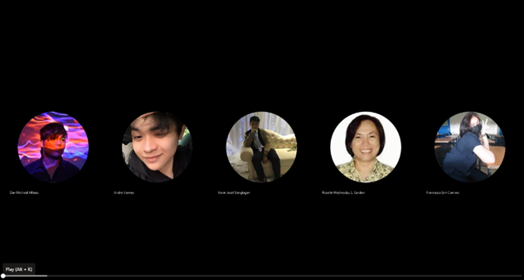

Project Consultation with Project Consultant | 40:11 minutes | October 25, 2022

* 1:11 – Discussing the SMART implementation in objectives.
* 1:38 – Checking the updated aims based on the panel comments.
* 4:51 – Removing some words in the objectives.
* 10:16 – Checking the ERD diagram.
* 15:45 – The project consultant suggested rewording the statistics to statistics.
* 19:54 – Checking the class diagram.
* 33:52 – Checking of data flow diagram
* 35:13 – Checking of Context flow diagram
* 38:06 – The project consultant suggested using the online library

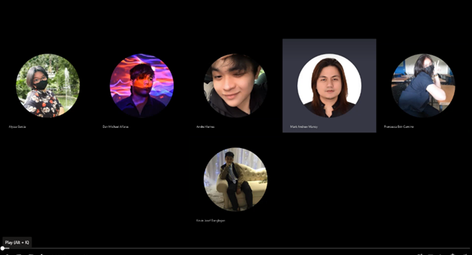

Project Review with Mr. Mark Andrew Manoy | 1:11:29 hours | October 25, 2022

* 2:07 – Checking the product backlog.
* 04:33 – Discussion of fixing the prioritization in the product backlog.
* 09:37 – Checking the updated specific objective.
* 12:27 – Checking the updated ERD diagram.
* 15:28 – Checking the RRL and its references.
* 18:10 – Discussion of implementation of security in the web-app
* 18:54 – Discussion of scrum expert team
* 25:44 – Checking the ERD diagram
* 27:33 – Checking the part diagram
* 32:00 - Checking the package diagram
* 34:31 – Checking the state machine diagram
* 37:52 – Checking the sequence diagram
* 41:06 – Checking the prototype images (fill out form)
* 55:25 – Checking the grammar in the technicality
* 1:00:08 – Checking the data flow.
* 1:03:29 – Rechecking the ERD

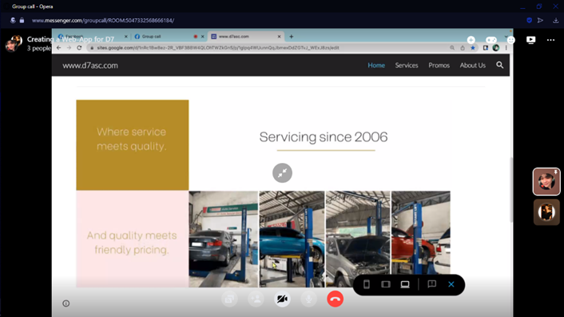

Meeting with client | 12:32 minutes | October 29, 2022

* 1:30 – The client requested to change the font of the web-app.
* 3:01 – Discussion about the 360 virtual tour features
* 4:39 – The client said they have problems with the bank transfer.
* 5:04 - The client agrees with the scan to pay system.
* 6:12 – The client disagrees with the reservation fee.
* 6:30 – The client agrees with the online logbook.
* 7:04 – Discussion about the competitors
* 7:37 – Discussion about the branch locator feature
* 7:58 – Discussion about the contact information of the company
* 8:30 – Discussion about the edge features
* 9:26 – Discussion about the difference between websites and web-app
* 9:45 – Discussion how the web-app can view on mobile.
* 11:37 – Inviting the client to join the presentation.

## Appendix G: Source Code

## Appendix H: Curriculum Vitae

## Appendix I: Links

* Sway: <https://sway.office.com/qC3syGHXTWRZmSJn?ref=Link>
* MSCPROJ Deliverables: <https://asiapacificcollege-my.sharepoint.com/:f:/g/personal/aoviernes_student_apc_edu_ph/En0YJpS0dNZKipKj7EZO19ABtSo6REnUQvBQ02EEqHSTbQ?e=Xfrh5f>
* GitHub: <https://github.com/seans888/Elite-4>